A Wearable Brain-Computer Interface

by

Payam Aghaeipour
payama@kth.se

Department of Communication Systems
School of Information and Communication Technology
Royal Institute of Technology (KTH)
Stockholm, Sweden

October 5, 2008

Supervisor: Dr. Rafael A. Calvo, Web Engineering Group (WEG), University of Sydney

Examiner: Dr. Peter Sjödin, Royal Institute of Technology (KTH)

ABSTRACT

In this thesis we have presented a system that uses the human ability to control a portable video game device through some electroencephalographic (EEG) rhythms. The neural signals obtained by EEG recording equipment are sent through a Bluetooth connection to a PC that processes it in real-time and sends it wirelessly to a mobile gaming device. BluesenseAD has been used as a Bluetooth device for sending EEG signals to a PC and we developed a BCI2000’s compatible driver for it. A new method for measuring delay in Bluesense driver has been proposed and further it has been shown that the system is reliable and robust enough to work in BCI systems.
In this study we have investigated the human’s ability to play a video game instead of the famous Cursor Task application by manipulating neuronal motor cortex activity in the presence of a visual feedback environment. The signals were obtained through a head-mounted neural interface and were mapped on the two control signals of a gaming device Breakout. The participants played the video game and Cursor Task alternatively by using their thoughts and their outcomes have been compared against each other which indicate that the game can be a good substitute for BCI’s output device.
Acknowledgement

Before anyone, I would like to express my most sincere gratitude to Rafael A. Calvo (my supervisor) that provided me with a unique environment of research and his fully support during the project. He acted further than his responsibilities and taught me about BCI systems. Without his support and patience it was impossible for me to complete this study. His constructive feedback beside his fantastic behavior was the best guide and motivation during the whole period of this study. Those will never be forgotten.
Many thanks to KTH, specially my examiner (Dr. Peter Sjödin,) that gave me the opportunity to accomplish my research in this field by letting me go to University of Sydney in Australia.
It would be unfair not to mention the profitable help of Gaetano Gargiulo who assisted me in Bluetooth driver development and evaluation by providing me with the test lab and giving me precious advices on this part of the project.
Many others in the department deserve mention as well, beginning with those in the group. Jorge Villalon, the other grad student in our lab, has provided valuable guidance and friendship on both academic and other matters. Omar Alzoubi helped me in the evaluation of the Video Game and setting up the BCI lab. Dr. Abbas Jamalipour provided technical assistance on Bluetooth part of this thesis and has always been a warm and supportive professor.
Contents
1. Introduction 1
2. Background 7
2.1. BCI Components (Signal acquisition, Signal Processing, Application) Classes, Categories 7
2.1.1. Signal Acquisition 7
2.1.1.1. Dependent Vs Independent BCI 7
2.1.2. Signal Processing 8
2.1.3. The output device 9
2.1.4. The operation protocol 9
2.2. Previous Researches 9
2.2.1. Existing BCI Design 9
2.2.2. Mu/Beta Rhythms 10
2.2.3. Current BCI Problems 11
2.2.3.1. Adaptation 11
2.2.3.2. Practicability 12
2.2.3.3. Artifacts 13
2.2.4. What portion of people is suitable for BCI? 13
2.2.5. Synchronous Vs. Asynchronous BCI 14
2.2.6. Imagery Tasks 14
2.3. Existing Solutions 15
2.3.1. BCI2000 15
2.3.1.1. BCI2000 Platform 16
2.3.1.2. Cursor Control Application 17
2.3.2. Suggested Architecture for Wearable BCI 18
2.3.2.1. What makes Practical BCI difficult to achieve 18
2.3.2.2. Successful Story, Wearable BCI 19
2.4. Dasher- text-entry Application 19
• 2-D Continuous Input: 21
• 1-D Continuous Input: 21
• Discrete Inputs: 21
2.5. J2ME 22
2.6. Bluetooth 23
2.6.1. Bluetooth Specification 23
3. Method 27
3.1. Wireless EEG Design 28
3.1.1. BluesenseAD Protocol 29
3.1.1.1. Bluesense Packet Formats 30
3.1.1.2. BluesenseAD Serial Connection Establishment Scenario 31
3.1.1.3. BluesenseAD A/D Configuration Scenario 32
3.1.1.4. BluesenseAD Start/Stop Sampling and Data Transmission 34
3.1.2. BluesenseAD Driver Design 36
3.2. Distributed Output Device 37
3.2.1. Client/Server Application Module 38
3.2.2. Breakout-Video Game 39
3.2.2.1. Game Controller 40
4. Implementation 43
4.1. Bluesense Driver Development 44
4.1.1. Serial communication in MS Windows 44
4.1.2. Protocol Implementation 45
4.1.3. BCI2000 Signal Acquisition Module 46
4.1.4. Compatible Driver for BCI2000 47
4.1.5. How Bluesense Driver works 48
4.1.5.1. BluesenseAD 48
4.1.5.2. BSController 49
4.1.5.3. BSProtocol 55
4.1.5.4. Tserial_event 57
4.2. Breakout, Video Game, Development 58
4.2.1. J2ME Network Programming 59
4.2.2. Breakout using TCP Connection 59
4.2.3. Breakout using UDP Connection 60
4.2.4. Breakout Implementation 61
4.2.4.1. TCPConnectionForm 62
4.2.4.2. TCPConnectionManager 64
4.2.4.3. TCPSender 66
4.2.4.4. Protocol 67
4.2.4.5. GameController 67
4.2.4.6. UDPConnectionForm, UDPConnectionManager, UDPSender 68
4.3. Game Server Development 69
4.3.1. Network Programming in Standard Java (Java SE) 69
4.3.1.1. TCP Programming 69
4.3.1.2. UDP Programming 70
4.3.2. Game Server Implementation 71
4.3.2.1. UDPBCIApp 73
4.3.2.2. UDPSender 74
4.3.2.3. Protocol 74
4.3.2.4. GameControl 74
4.3.2.5. TCPServer 75
4.3.2.6. UDPServer 77
5. Analysis 79
5.1. BluesenseAD Evaluation and Validation 79
5.1.1. Delay in BluesenseAD Driver 79
5.1.1.1. Results and discussion 82
5.1.1.1.1. One Active Channel 82
5.1.1.1.2. Four Active Channels 84
5.1.1.1.3. Eight Active Channel 85
5.1.1.1.4. Summary of Results 86
5.1.2. BluesenseAD Scalability 87
5.2. Video Game, Breakout, Evaluation 89
5.2.1. Parameters Definition 90
5.2.2. Method 91
5.2.3. Results and discussion 92
6. Conclusions and Future Work 97
6.1. Conclusion 97
6.2. Future Work 98
7. References 101

List of Figures
Figure ‎1.1: BCI as a Control System 1
Figure ‎2.1: Cursor Control Application [reproduced from [40], with permission of BCI2000 Wiki] 17
Figure ‎2.2: User Interface of Dasher 20
Figure ‎2.3: Bluetooth Specification Protocol Stack 24
Figure ‎3.1: Our Proposed Architecture for Wearable BCI 27
Figure ‎3.2: BluesenseAD Serial Connection Establishment Scenario 31
Figure ‎3.3: BluesenseAD A2D Configuration Scenario 34
Figure ‎3.4: BluesenseAD Start/Stop Sampling and Data Transmission 35
Figure ‎3.5: Overview of Bluesense Driver for BCI2000 Signal Acquisition Module 36
Figure ‎3.6: Client/Server Application Module 38
Figure ‎3.7: Breakout-Video Game, developed under Java Netbeans can easily be ported on any mobile (PDA) device. 40
Figure ‎3.8: Connection Settings layout for Breakout game 42
Figure ‎4.1: BluesenseAD Schematic Source Code 49
Figure ‎4.2: Overview of the Bluesense controller class 49
Figure ‎4.3: SerialEventManager schematic source code 51
Figure ‎4.4: pseudo code for OnDataArrival method 52
Figure ‎4.5: Source code of wait_for_data_block method 55
Figure ‎4.6: BSProtocol class. No logic is implemented here and only compatible packets are generated by these methods. 56
Figure ‎4.7: Tserial_event class. Only public methods of this class are shown in this figure. 58
Figure ‎4.8: Breakout, Video Game, developed under Java Netbeans can easily be ported on any mobile (PDA) device. 62
Figure ‎4.9: Singleton TCPConnectionFrom class. This object cannot be instantiated, only can be access via getConnectionForm method. 63
Figure ‎4.10: TCPConnectionManager class including all its methods and the pseudo code for receiving packet. 65
Figure ‎4.11: TCPSender class including all its methods 67
Figure ‎4.12: Game Server application layout before and after connection setup with the video game 72
Figure ‎4.13: UDPBCIApp class, including all its method and some pseudo code 73
Figure ‎4.14: GameControl interface, other classes have to implement all these methods in order to be able to control the game. 75
Figure ‎4.15: TCPServer is responsible to setup connection to the Game and controls it using GameControl methods 77
Figure ‎5.1: Method for measuring the Bluesense driver delay. Left figure shows the sampled signal in Bluesense and the right figure illustrates the sampled signal of National Instrument device. 80
Figure ‎5.2: BluesenseAD sampled triangular signal at minimum point. The exact minimum cannot be defined. 81
Figure ‎5.3: Unacceptable sampled data because of high frequency sampling 88

List of Tables
Table ‎3.1: Bluesense Packet Structure 30
Table ‎3.2: Status of START_STOP_ADC_CFM command 35
Table ‎5.1: Measured Delay (in millisecond) for various Block size and sample rate (in Hertz) using one active channel 83
Table ‎5.2: Measured Delay (in millisecond) for various Block size and sample rate (in Hertz) using four active channels 84
Table ‎5.3: Measured Delay (in millisecond) for various Block size and sample rate (in Hertz) using eight active channels 86
Table ‎5.4: The behavior of BluesenseAD driver for various configurations 87
Table ‎5.5: Maximum sampling rate for various numbers of channels, values are presented in Hertz 89
Table ‎5.6: Four participant’s statistics, first table for each subject shows the results for Cursor Task while the second table presents Breakout outcomes 94

Introduction
Brain-Computer Interfaces (BCI) technology is a new and fast-evolving field of direct interaction between the human neural system and machines, aiming to augment human capabilities by enabling people (especially disabled) to communicate and control devices by mere “thinking”. If BCI is considered as a control system, it has input, output, components that translate input into output, and a protocol that determines the timing operation. Figure 1.1 shows these modules and their interactions.

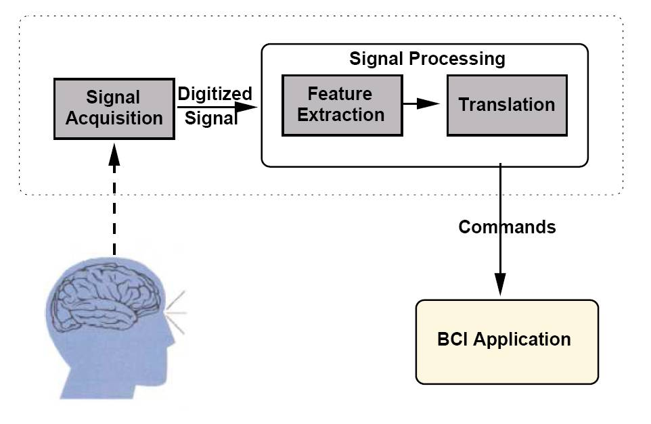
Figure ‎1.1: BCI as a Control System

Signal Acquisition module acquires brain’s signals, digitalizes and transfers them to a Signal Processing module. The Signal Processing component is responsible for extracting appropriate features of signals and applying translation algorithm on the features to generate the device commands. These commands can be further used by application to perform a specific task.

BCI systems encompass a number of disciplines not only from the medical domain but also the technology spanning from the software, hardware, telecommunications, and so forth. Acquiring signals needs the knowledge of anatomy, chemistry, and physiology. Signal processing module depends on computer hardware and software. Adaptation routines are based on learning principals and on other human factors like attention, motivation, and fatigue. Output control devices have specific electronic or mechanical parts. Finally, operation protocols combined all modules together and orchestrate them while telecommunication provides communication protocols between different modules, both for wireless and wired connection. Thus, BCI research involves neurobiology, psychology, engineering, applied mathematics, computer science, and telecommunications.

BCI is still in its earliest stages and it is not clear how far the field can or will go. There are a number of critical issues that can effect on the progress of the BCI field such as, selection of signal acquisition methods, signals features, feature extraction methods, translation algorithms, output devices, and operational protocols.

Today, Electroencephalography (EEG) is the most commonly used as a signal acquisition method in BCI. A number of research labs using EEG as acquisition method has been increasing during last decade. Current EEG recording systems usually consist of many wires going from user’s head to the recording device. Thus the EEG cap wearer cannot move easily and should stay still during the entire recording. Wireless EEG has been taken to account after a huge progress in wireless technologies. In less than a second, millions of bits can be transferred over the air by using such small chipsets. The next generation of EEG has no choice but to be wireless enabled.

The classical signal processing approach is to establish EEG-based control by setting up a system that is controlled by a specific EEG feature and to let the subjects learn the voluntary control of that feature and using those features to generate control signals, a process that may well require several weeks or month. In recent years a machine learning approach to BCI has been getting more attention among the research groups. This new approach let the system adapt to the individual brain signatures of each user, thereby drastically reducing or even eliminating the need for subject training. Usually, machine learning algorithms are computational intensive so they cannot be run on the small devices like Personal digital assistant (PDA).

Translations algorithm or classifiers generate commands to control an output device. This device could be any controllable machines, but in the current BCIs the output device is mostly a computer screen and the output is the selection of targets or cursor movement. Cursor movement is a good prototype because it is objective, easily implemented, simple for the user to learn, and can serve as a prototype for control of a wide variety of applications [1]. However, it does not completely reflect the normal situation that BCI systems are going to be used. It can only run on the same computer that other components are running. Limited number of BCI systems uses an actual output device, for example: a brain-actuated wheelchair. The subject guides the wheelchair through a maze, using a BCI that recognizes the subject’s intent from analysis of noninvasive EEG signals [2]. Currently, these devices are in very basic level and it is really hard to say when they can reach to acceptable results. Besides these two extremes, there are some systems that using virtual reality [3]. These environments provide an excellent tool to test procedures or virtual body parts which might be applied subsequently in reality, e.g., for patients with disabilities.

Various architectures have been proposed for BCI, but all of them almost consist of the same four modules. The only actual different is the variety of platform they can support (e.g. PC, PDA) and/or if the components can operate separately on different machines. For instance: Wadsworth proposed BCI2000 as a general-purpose system for brain-computer interface research. BCI2000 can also be used for data acquisition, stimulus presentation, and brain monitoring applications [4]. An interesting thing about BCI2000 is its distributed architecture. Each module could be run in a different machine and platform. However, the BCI2000 has been written for MS Windows OS and it is really cumbersome to port it on other platforms such as pocket pc. Another example of this kind of architecture is “Graz BCI” (an EEG-based BCI system) [5]. The BCI-lab at Graz University of Technology, Austria has developed this system and various applications for it including spelling devices, computer games, functional electrical stimulation (FES), and navigation in virtual environments.
Another approach is to move all the components on the mobile device such as PDAs. One of these system has been introduced in [6]. Transferring BF++ framework on the 100-MHz CPU device has been developed and evaluated successfully. However, this system may not work for more intensive classification algorithm due to the low capacity of these devices. By moving less computational intensive modules such as “Output” on PDA and keeping Signal Processing on the PC, we can gain both mobility and high CPU power benefits.

As a summary, current systems suffer from too many wires from user’s brain to the recorder device, heavy equipment needed to be attached to the user, low mobility, and slow signal processing due to limited power on PDAs. Our architecture has solved all these issues by introducing wireless EEG, keeping computational intensive modules on the PC and moving application on mobile device (e.g. PDA). In addition, the implemented application can operate in two predictable and unpredictable modes. While predictable mode is more like cursor control on the screen, unpredictable mode simulates real environments.

The evaluation of BCI performance contains two levels: the user and the system [7]. The user must control the signal features, and the system must recognize that control and translate it into device control effectively. There is a way to evaluate the user performance, but it is in a less interest at this point because the current project is more about system part. Evaluation of system performance has two parts: performance in a specific application and theoretical performance. In a specific application (e.g. proposed game) the performance can be defined as the speed or accuracy of the bar control. We defined 7 different variables to measure the performance of our application such as: hit, miss, abort, number of correct movement and number of wrong movement both for right and left. Measurement of theoretical performance is not a concerned at this research. One important phase of evaluation is testing in circumstances like those of real-life applications. This testing can reveal how well the BCI adapts to spontaneous variation in the signal features when it does not have the advantage of knowing what the output is supposed to be. The breakout game as an application for BCI has the ability to be simply changed to unpredictable or predictable user’s intent. The game has been kept as similar as possible to the Pong application to enable the user to switch to this application easily. As a system developing point of view, the game has been run on two different PDAs and has been used for a complete recording sessions and the result has been compared to the existing Pong application.
The evaluation of the other part of this project, the wireless EEG, has been done by comparing the performance of current wired solutions against ours. We measured the Bluetooth delay and we showed that the wireless connection will not affect the whole BCI system, thus it can be used as an alternative acquiring system.

This master thesis is organized into the following chapters:
- Introduction
- Background
- Method
- Implementation
- Analysis
- Conclusions and Future work
- References

Chapter 1 gives an introduction to BCI systems and the importance of this research in current field. Chapter 2 contains review and commentary of literature relevant to BCI, Bluetooth and J2ME technologies. It provides an overview of EEG recording, including basic signal acquisition and processing, current well-known BCI systems and available solutions for wearable BCI. This chapter also goes through the Bluetooth technology and overview of the Bluetooth protocol stack. The J2ME which will be used in later sections is also discussed in this chapter.
Chapter 3 describes the methodologies we used for developing our wearable BCI. The design for Bluetooth driver and Game Server are provided in this chapter. One should read this chapter before getting into the implementation chapter to achieve the overview of the systems.
Chapter 4 discusses the technologies that have been applied for development of this project. C++ language has been used for developing Bluetooth driver while Video Game and Game Server have been written in Java language. It also gives an insight understanding of the applications’ code by going through the implementation of each class.
Chapter 5 describes the evaluation of BluesenseAD driver and the Video Game. A new method for measuring delay in Bluesense driver is proposed and further it is shown that the system is reliable and robust enough to work in BCI systems. The Video Game is compared with the standard output application (cursor task) and result is presented. It is demonstrated that the game can be a good substitute for BCI’s output device.
Chapter 6 presents a summary of the studies and their contributions to the field, suggestions for future directions, and concluding comments. At last, the references section list the works cited in this report.

Background

BCI Components (Signal acquisition, Signal Processing, Application) Classes, Categories

Signal Acquisition
Brain signals can be collected in different ways, one of these methods is EEG. The EEG based communication attracted little serious scientific attention until recently, for at least 3 reasons. First, the possibility of recognizing a command beside the complexity, distortion, and variability seemed to be low. Second, until recently the required technologies were so expensive or did not exist. Third, old generation EEG-based BCI had so limited communication capacity and it looked very unlikely to be suitable for control [7].
Based on signal acquisition method, BCI can be categorized by whether it uses non-invasive (e.g. EEG) or invasive (e.g. intracortical) methodology. BCI can also be classified by whether it uses evoked or spontaneous inputs. Evoked inputs are generated by flashing events while spontaneous inputs do not depend on such stimulation for being generated.

Dependent Vs Independent BCI
The BCIs can be classified into two classes: dependent and independent. In a dependent BCI, the brain’s output channel is EEG, but the generation of the EEG signal depends on the other physical movement (e.g. gaze direction). In contrast, an independent BCI only depends on the user’s intent, not on the output pathways of muscles. For people with the most severe neuromuscular disabilities, independent BCIs are more useful.

Signal Processing
The Signal Processing component is responsible for extracting appropriate features of signals and applying translation algorithm on the features to generate the device commands.

- Feature Extraction
Different methods could be used for feature extraction. “Correlation” [8] and “Estimation of the Power Spectrum” [9] are two methods that commonly used.
- The Translation Algorithm
After the features have been extracted the translation algorithms should decide how to generate commands based on the signal features. These commands may be continuous or discrete. They should be as independent as possible, for example horizontal movement should not depend on vertical movement [7]. The success of a translation algorithm is determined by the appropriateness of its selection of signal features, many researches have been done to determine the most effective features in the brain signals [8, 9].
These algorithms adapt to each user on 3 levels. First, when a user uses the BCI for the first time, the algorithm adapts to the user’s signal features. Second, brain signals may be changed based on the different factors such as, time of day, hormonal levels, immediate environment, and illness. To keep the algorithm adapted to the condition, periodic online adjustments are needed to reduce the impact of those spontaneous variations. The third level of adaptation engages the adaptive capabilities of the brain. The brain has the ability to modify the signals features to improve BCI operation.

The output device
This device could be any controllable machines, but in the current BCIs the output device is mostly a computer screen and the output is the selection of targets or cursor movement. Furthermore, they are only suitable for basic control (e.g. temperature, lights, television), for answering yes/no questions, and for word processing at slow rates. They might also operate devices like a wheelchair. If the speed and accuracy can be improved, the range of applications would increase. Up to now, most BCIs have been evaluated in the lab situation and only a few studies have explored BCI integration into real life. A lab application may get less attention in the normal life because of the poor user interaction.

The operation protocol
This protocol defines how the system is turned on and off, whether communication is continuous or discontinuous, the sequence and speed of interactions between user and system, and what feedback is provided to the user.

Previous Researches

Existing BCI Design
- Mu/Beta Rhythms and Cursor Control: Most adults display 8–12 Hz and/or 18–26 Hz rhythms in the EEG recorded over primary sensorimotor cortices. Normally, amplitude increases and decreases that are related to sensory input and/or movement or motor imagery are seen in these rhythms (see [10] and [11]). Many researches have reported that BCI users could learn to control Mu/Beta rhythms and use that control to move a cursor to targets on a computer screen (e.g., [12], [13], [14], and [1, 15, 16]).

- Slow Cortical Potentials and Cursor Control: Slow cortical potentials (SCPs) are negative or positive polarizations of the EEG or magnetic field changes in the magnetoencephalogram (MEG) that last from 300 ms to several seconds. Negative and positive SCPs are typically associated with functions that involve cortical activation and deactivation, respectively (see [17] and [18]). Same as sensorimotor rhythms, people can learn to control SCPs and thereby control cursor movement on the screen (see [19], [20] and [21]).

- P300 Potential and Spelling: A positive response in the EEG over parietal cortex about 300 ms after infrequent stimulus presentation called the “P300” potential (see [22-24]). This response has been used as the basis for a BCI system (see [25], [26], and [27]). As an example, a 6*6 matrix of characters in which the rows and columns flashed successively and randomly at a rate of eight flashes per second has been used as a spelling application for P300 potential. The user selected a character by focusing attention on it and counting how many times it flashed.

Mu/Beta Rhythms
Since this project has been designed and evaluated using Mu and/or Beta rhythms, they will be discussed in more details in this section.

In awake people, even when they are not engaged in processing sensory input or producing motor output, primary sensory or motor cortical areas often display 8–12 Hz EEG activity (Mu Rhythm) [28]. Computer-based analyses show that mu-rhythm activity comprises a variety of different 8–12 Hz rhythms, distinguished from each other by location, frequency, and/or relationship to concurrent sensory input or motor output. These mu rhythms are usually associated with 18–26 Hz beta rhythms. While some beta rhythms are harmonics of mu rhythms, some are separable from them by topography and/or timing, and thus are independent EEG features [11, 29, 30]

Several factors suggest that mu and/or beta rhythms could be good signal features for EEG-based communication. Movement or preparation for movement typically causes a decrease in mu and beta rhythms. This decrease has been labeled ‘event-related desynchronization’ or ERD [11, 31]. Its opposite, rhythm increase, or ‘event-related synchronization’ (ERS) occurs after movement and with relaxation [11]. Furthermore, and most relevant for BCI use, ERD and ERS do not require actual movement, they occur also with motor imagery (i.e. imagined movement) [30, 32]. Thus, they might support an independent BCI. Since the mid-1980s, several mu/beta rhythm based BCIs have been developed. The Wadsworth BCI [33] and the Graz BCI [34] are two successful example of this type of BCI.

Current BCI Problems
The problems that remain unsolved even with the most current and successful systems are the slow training of subjects, artifacts, and practicability of BCI in real life. Precise positioning of the controlled cursor has so far not been achieved. What adds to the difficulty of this research is that a new subject does not know what thought patterns are going to give the best results, so initially the subject and machine are learning in parallel [1]. The BCI problems are not limited to adaptation, artifacts and practicability, but these issues are almost common in all BCI research, hence they will be discussed in details.

Adaptation
In BCI experiments, where feedback is given to the subject, the classification accuracy improves with increasing number of sessions. This has, however, not always happened, as shown in a BCI experiment no significant increase above 80% was found with increasing number of feedback sessions [35]. This may be explained by the fact that two systems (man and machine) are strongly interdependent but have to be adapted independently. The starting point of this adaptation is the training of a “machine” to recognize certain EEG patterns of a subject. During this phase, no feedback is given. As soon as feedback is provided, each feedback results in an adaptation of man to machine: man tries to repeat success and avoid failure. [35]

A lot more researches have to be done, to make the adaptive algorithms available for the BCI systems. Besides these two adaptations there is another level of adaptation which could be accomplished only by periodic online adjustments in order to reduce the impact of spontaneous variations (e.g. fatigue, illness and hormonal levels).

Practicability
In order to make future BCI practical, the following three constraints have to be satisfied [1]:

- Minimize the training time for the final user. Current systems often require weeks of training before reasonable performance is achieved. Long training is usually one of the main reasons for less acceptance of the system.
- Use as few EEG electrodes as possible. A BCI with too many electrodes becomes costly, cumbersome, long montage time, and less feasible for future implantation.
- Achieve sufficiently high accuracy to provide a reliable interface between the user and the computer.

The adaptation which was discussed earlier can effectively reduce the training time; however it still is an open problem. Some studies have shown a limited success by using small number of electrodes (see [3]). But they also have raised more number of unresolved issues, for example Pfurtscheller in [3] has brought up the question whether two or three bipolar channels are sufficient to achieve higher classification accuracies between motor imagery and rest, which has to be answered before it could be applied.

Artifacts
Muscle activation and eye movement can contaminate the EEG signals for example, frontals muscle EMG can dominate the beta- or mu-rhythm frequency range at frontal locations, and eye blinks can affect the theta- or even mu-rhythm range at frontal or central locations. So, more analysis and research that can detect these kinds of artifacts and the methods to prevent them are highly significant in BCI research.

What portion of people is suitable for BCI?
Some studies have demonstrated that not all the participants in the BCI can achieve a good control on their brain signals. For example, only 12% of the subjects can get an accuracy of better than 80% after only about 10 min of training among 324 visitors participated voluntarily in a BCI field study. Further, 78% of the subjects have been classified with accuracy between 60%–80% and only in 10% no discrimination between brain states has been achieved [35].

In another research, it has been mentioned an unsuccessfulness of the BCI experiment on about 50% of the subjects [2]. Below are the detailed results.
- About 20 percent of subjects don’t show strong enough motor-related mu-rhythm variations for effective asynchronous motor-imagery BCI,
- Another 30 percent exhibit slow performance (< 20 bits per minute), and
- Up to 50 percent exhibit moderate to high performance (20–35 bits/min.).

As it was mentioned above, it is obvious that all the subjects cannot reach to the same level of control in BCI, but it is not clear the proportion of people who can achieve the good results. This is also another open problem which should be studied in later studies. However, by recording enough data and applying offline analysis, to some extent, it can be determined whether the subject is suitable for BCI.

Synchronous Vs. Asynchronous BCI
In the synchronous BCI, the brain signal, in our case the EEG, is analyzed and classified synchronously to each cue stimulus in fixed, predefined time windows. Thus, this system is called a synchronous BCI. After each cue stimulus the subject has to act and produce a specific brain state [35]. On the other hand, in asynchronous BCI, no cue stimulus is necessary and the user intends an operation at free wish which is called asynchronous BCI. The fact that makes an asynchronous protocol more demanding and more complex than synchronous BCI is its requirements to the continuous sample-by-sample analysis and feature extraction of the recorded signal. One of the major problems is to discriminate between intentional brain states and unintentional states. In other words, in an asynchronous BCI, no output signal should be produced either during the resting or idling state or during unintentional brain states. Therefore, while a synchronous BCI has to discriminate only between two intentional states, an asynchronous BCI has to discriminate between three states, i.e., two intentional states and one unintentional state [3]. Some rudimentary studies of asynchronous BCI has been discussed in [36], [37], and [38].

Imagery Tasks
Same motor imagery task for the entire subject may not result in the good performance, thus each subject should use different motor imagery strategies, i.e., right versus left hand, right hand versus tongue, and left hand versus foot. Then the results have to be analyzed and the best strategy be selected for each user. Various imagery tasks can be detected in different frequency band or different scalp position, for example: the foot motor imagery induced long trains of 17-Hz beta oscillations focused on the electrode position near the vertex (Cz).[5]

Existing Solutions
In this section, an overview of existing BCI systems which have some sort of relation to our project will be mentioned. First, BCI2000 which we used as a platform for our BCI research will be explained. Then, a short summary about other studies in wearable BCI will be briefly discussed.

BCI2000
BCI2000 is a general-purpose system for brain-computer interface (BCI) research. It is intended to help BCI research and development. It provides a flexible general-purpose platform that facilitates the evaluation, comparison, and combination of brain signals, translation algorithms, applications, and operating protocols. BCI2000 can reduce the time, effort, and expense of testing new designs and also provide a standardized data format for offline analyses [4]. In the following paragraphs, the BCI2000’s modules will be explained.

- Source Module: The source module digitizes and stores brain signals and passes them on without any further preprocessing to signal processing. It consists of a data acquisition and a data storage component. Data storage stores the acquired brain signal in a standardized data format file [4].
- Signal Processing Module: The signal processing module converts signals from the brain into signals that control an output device. This conversion has two components: feature extraction and feature translation. In the first component, the signal major features are extracted from the signals received from the source module. In the next component, a translation algorithm translates these signal features into control signals which further are sent to the user application module. The filters in BCI2000 are completely independent, thus, they can be combined or interchanged without affecting others [4].
- User Application Module: The user application module receives control signals from signal processing and uses them to drive an application. This module is augmented with connector component which enables BCI2000 to transmit all the control signals over user defined IP address and UDP port [4].
- Operator Module: The operator module defines the system parameters (e.g., the trial length in a specific application or a specific signal processing variable). In addition, operator can display information (e.g., a text message or a signal graph) sent to it from any other module. This allows a user to view real-time information about online events (e.g., display of unprocessed brain signals) [4].

BCI2000 Platform
The BCI2000 system model can be written in any programming language, any development environment, and any operating system. However, the existing system is written in C++ language and Borland C++ Builder is used as the development environment which can offer an excellent rapid-application development platform for C++ [4].
Currently, BCI2000 can only run on the Microsoft Windows™ 2000/XP that offers the most auxiliary components (e.g., hardware device drivers). While this operating system, like most operating systems, is not a real-time system (i.e., the time course of events is not deterministic), BCI2000’s developers claim that the software has been designed to depend as little as possible on potentially lengthy operating system functions, and consequently the time course of online operation for current implementations of BCI2000 were successfully assessed [4].

Cursor Control Application
The purpose of the Cursor Control is to provide a BCI2000 User Application module that can realize 1D, 2D, or 3D cursor movement tasks. It displays a box-shaped scene in which a ball-shaped cursor moves [40]. The goal is to hit the ball to the target in the certain given time. This application has 5 different stages. As it can be seen in the Figure 2.1, all these stages are clearly timed which makes this application ideal for asynchronous BCI evaluation (see Section 2.2.5).

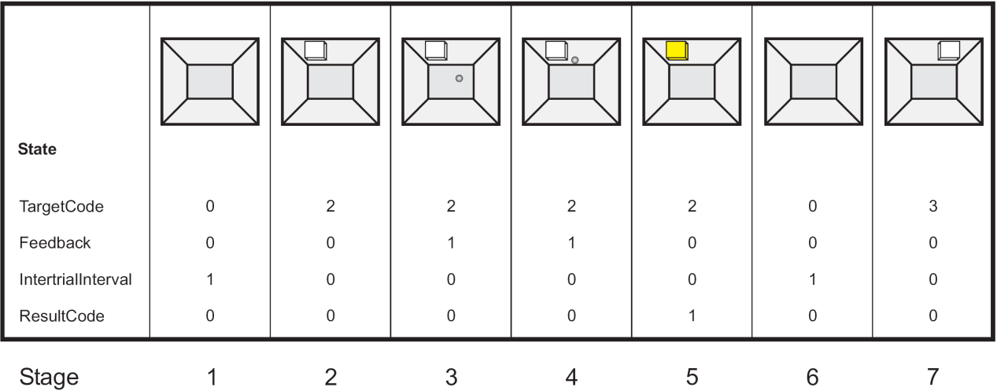
Figure ‎2.2: Cursor Control Application [reproduced from [40], with permission of BCI2000 Wiki]

This application consists of five subsequent stages (as illustrated in the Figure 2): Stage 1, the screen shows an empty workspace. Then, a target appears in one out of n possible locations. After the pause in stage 2, the cursor appears in stage 3. It immediately starts to move by receiving the 3-dimensional control signal. During stages 3 and 4, the user is trying to reach the cursor to the target. Stage 4 can end in one of three ways: the cursor hits the target, it misses by hitting any other side, or the aborts by occurring time-out. In Stage 5, the cursor disappears and the target changes its color to indicate completion of the trial period. After a certain duration, the target disappears and the next trial starts [40].

Suggested Architecture for Wearable BCI
Navarro in [41] proposed the use of wireless technology in a wearable computer interface in order to accomplish the mobility required. The tri-wireless Wanda PDA which supports three communication technologies (Bluetooth, 802.11b and GSM/GPRS) has been suggested as a mean of communication between the wearable BCI and the world. Bluetooth technology has been introduced as the main communication channel between the BCI and the PDA. The Global System for Mobile Communication and General Packet Radio Service (GPS/GPRS) can be augmented if BCI is indented to be context aware and location. She further has mentioned that the WLAN 802.11b technology could connect the user to the LAN environments such as: home or office.

Further in [41], Navarro has highlighted four factors that should be taken to consideration in order to improve BCI practicability and public acceptability:
- Using Human Computer Interaction principles in the design of BCI devices so that they may become acceptable wearable devices.
- Employing Augmented Reality (AR) to improve mobility capabilities.
- Incorporating wireless technologies for mobility enhancement and context awareness.
- Making the BCI transparent that allows the user to accomplish the daily activities in a more efficient manner.

What makes Practical BCI difficult to achieve
The variables have more dynamicity in the real world situation than the experimental environments which makes the incorporation of BCIs as a wearable computer into real world more difficult. “Most of the experiments are mainly performed in laboratories in front of a computer screen with controlled variables. This situation is difficult to recreate when exposing the BCI out into a real world nomadic environment (e.g. outdoors where there is no computer screen, a PDA is an alternative)” [41].

Successful Story, Wearable BCI
In [6] a successful report of transferring BF++ framework on the 100-MHz CPU device has been reported. This can be considered as a successful transition of the whole BCI system to the portable device. Even with an acceptable outcome from signal processing module, this system suffers from the ability to incorporate the machine learning algorithms which usually need more computational power.

Dasher- text-entry Application
An alternative application for BCI which seems to be more useful is Dasher [42]. Dasher is an information-efficient text-entry interface, driven by natural continuous pointing. Dasher is a text-entry system wherever a full-size keyboard cannot be used, for example:
- joystick, touchscreen, trackball, or mouse;
- head-mouse or eyetracker;
- on a palmtop computer;
- on a wearable computer.
Dasher combines with a language model, gives the user an effective way to enter text. The language model predicts the probabilities of the characters that the user may write next and a user-interface will show it in the way that the user can select it easier. DASHER is free, open-source software [42].
To write a phrase starting with the word “HELLO” the user first selects the letter “H” among the all 32 characters. As the box containing “H” fills more of the screen, the user can see again all the 32 characters in the sub-boxes. By selecting “E” letter the same process will be continued. The language model in each step of selection makes the more probable letters to be represented in bigger boxes and next letter can be chosen simpler. Figure 2.2 illustrates the user-interface of the Dasher.

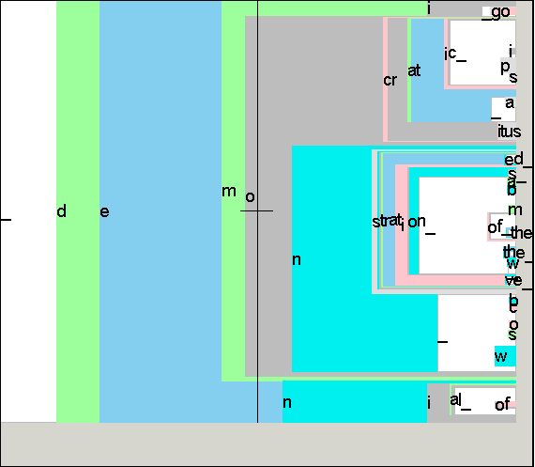
Figure ‎2.3: User Interface of Dasher

Dasher’s language model is initialized using example text written in the user’s language, and continuously adapts to the user’s writing style. Dasher supports different input devices. And according to each input device the Dasher could be controlled differently, for example the zooming and letter selection differs when “Breath Mouse” is used instead of Mouse control. The “Breath Mouse” is one-dimensional control device whereas Mouse is two-dimensional. Below some of the input devices used with Dasher are discussed.

2-D Continuous Input:
The first version of Dasher was developed to be driven by two-dimensional input, i.e. by controlling the cursor on the screen. One dimension (e.g. vertical) is used to select the letter and the other dimension to control the zooming speed. The research shows Dasher is an effective method of text-entering, using mouse control a user after 1 hour practice can reach writing speed of 25 words/min and an expert user could achieve 35 words/min [43]. Using only eye control, an intermediate user can write at the speed of 25 words/min [44].

1-D Continuous Input:
For input devices with a single continuous dimension control, Dasher maps one-dimension input onto a continuous curve within two-dimensional space. The extreme values allow the user to zoom out or pause the interface while the midrange value could be used to control the direction and to select the character. A “breath mouse” which provides one-dimensional control by measuring the stretching and contraction of a belt as the wearer breathes in and out, could be used as an input for the Dasher. A beginner users reached an average of 6 words/min after 1 hour practice and an expert user could write at the speed of 16 words/min [45].

Discrete Inputs:
By pressing buttons Dasher could be controlled. The simplest method is using two buttons. One is used for zooming top half and the other for zooming bottom half. Dasher converts the bits to the text and the efficiency is provided by language model. Current language model can compress English test to around 2 bits per character. So, user can write one character for every two button presses.

J2ME
Java Micro Edition (Java ME or J2ME) is an environment for running applications on mobile and other embedded devices such as, Mobile phones and PDAs. Java ME includes user interfaces and built-in network protocols [46].
The Java ME technology is based on three elements:
- A configuration provides the most basic set of libraries and virtual machine capabilities for a broad range of devices,
- A profile is a set of APIs that support a narrower range of devices, and
- An optional package is a set of technology-specific APIs.
The configuration for small devices is called the Connected Limited Device Configuration (CLDC) [47] and the more capable configuration is called the Connected Device Profile (CDC). On top of the different configurations Java ME platform also specifies a number of profiles defining a set of higher-level APIs that further define the application. A widely adopted example is to combine the CLDC with the Mobile Information Device Profile (MIDP) [48] to provide a complete Java application environment for mobile phones and other devices with similar capabilities. In the other word, CLDC specifies the minimum supports and MIDP determines higher supports over the CLDC.
Currently, CLDC has got two different specifications:
- CLDC 1.1: CLDC 1.1 is a revised version of the CLDC 1.0 specification, and includes new features and other enhancements. CLDC 1.1 is backward compatible with CLDC 1.0.
- CLDC 1.0: Minimum specification
Currently, MIDP has got two different specifications:
- MIDP 2.0: MIDP 2.0 is a revised version of the MIDP 1.0 specification, and includes new features such as an enhanced user interface, multimedia and game functionality, and greater connectivity. MIDP 2.0 is backward compatible with MIDP 1.0.
- MIDP 1.0: Minimum specification

Bluetooth
Bluetooth wireless technology, which carries voice, data and video [49], has been designed within the communication industry to address portable communications and computing needs in economic and societal environments. Bluetooth is a low cost, low power radio communication technology that operates on 2.4 GHz frequency [50]. It does not require line of sight (e.g. Infrared technology) and therefore is able to operate in areas with high interference as it uses frequency hopping.
Bluetooth is split into two sections, the Bluetooth Specification and Bluetooth Profiles. The specification describes the Bluetooth architecture and also how this technology works, while the profiles explain how the Bluetooth can be used (e.g. SPP (Serial Port Profile)).

Bluetooth Specification
This section describes how Bluetooth technology works. Same as other communications protocol, Bluetooth consists of different layers which cover from radio to application [51]. Figure 2.3 illustrates Bluetooth Specification Protocol Stack.

Bluetooth Radio
Baseband
(LMP) Link Manager Protocol
L2CAP Layer
Host Controller Interface (HCI)
RFCOMM
SDP (Service Discovery Protocol)
Figure ‎2.4: Bluetooth Specification Protocol Stack

- The Radio layer is the lowest layer of the Bluetooth specification. The requirements for the Bluetooth transceiver device which is operating in the 2.4GHz band, is defined in this layer. A frequency hopping in 79 hops displaced by 1 MHz, starting at 2.402GHz and finishing at 2.480GHz, is used in Bluetooth [52].
- The Baseband specifies the medium access procedures between Bluetooth devices [53]. It manages physical channels and links besides other services such as error correction, data whitening, hop selection and security [54]. “The Baseband also manages asynchronous and synchronous links, handles packets and does paging and inquiry to access and inquire Bluetooth devices in the area” [54]. A physical link which represents a Baseband connection between devices has five common properties, Power control, Link supervision, Encryption, Channel quality-driven data rate change, and Multi-slot packet control [53].
- The Link Manager Protocol (LMP) controls and exchanges information which is needed to establish connection between two devices. Thus, setting up and control of both logical and physical links are specifies in this layer [55]. The Link Manager Protocol consists of various type of PDU (protocol Data Units), which are determined by the AM_ADDR (Active Member Address) in the packet header, exchanged between two devices [56]. These PDUs enabling many messages such as: Connection Establishment, Power control, Quality of service, Authentication, Pairing, Encryption, Name Request, Hold Mode, and Sniff Mode.
- The Host Controller Interface (HCI) provides a uniform method of accessing the Bluetooth baseband capabilities by providing a command interface to the baseband controller and link manager [57]. These Commands are implemented by accessing baseband commands, link manager commands, hardware status registers, control registers and event registers in Bluetooth hardware.
- The Logical Link Control and Adaptation Protocol (L2CAP) allows higher level protocols and applications to transmit and receive L2CAP Service Data Units (SDU) up to 64 kilobytes in length. L2CAP provides higher level protocol multiplexing, packet segmentation and reassembly through connection-oriented and connectionless data services. L2CAP also supports the Flow Control and Retransmission Modes which permits per-channel flow control and retransmission [58].
- The RFCOMM protocol provides emulation of serial ports over the L2CAP protocol. The protocol is based on the ETSI standard TS 07.10. But only a subset of the TS 07.10 standard is used and some adaptation is applied [59]. In theory the RFCOMM protocol can support up to 60 simultaneous connections between two Bluetooth devices. However, the number of connections that can be used simultaneously in a Bluetooth device is implementation-specific.
- The Service Discovery Protocol (SDP) provides a means for applications to discover which services are available and to determine the characteristics of those available services [59]. A specific SDP is needed in the Bluetooth environment, as the set of services that are available changes dynamically based on the mobility of Bluetooth-enabled devices.

Method
In this project, we developed a new distributed architecture to address two needs of wearable BCI, mobility and performance. While mobility has been added by introducing a wireless EEG acquisition machine and wireless application device, performance is kept the same as previous BCI solutions. This has been done by keeping the entire computational intensive tasks (e.g. machine learning) on the stationary computers like laptop. Our distributed architecture is illustrated on Figure 3.1.

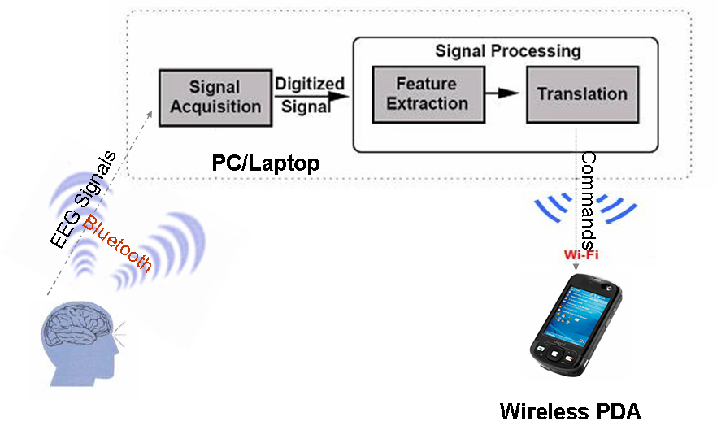
Figure ‎3.5: Our Proposed Architecture for Wearable BCI

The EEG signals are acquired by the usual wet or dry electrodes, but instead of being connected by wires to the stationary computer, they are connected to the small Bluetooth device. The BluesenseAD was selected as a Bluetooth chipset which has 8 analog to digital channels and is able to sample the data at the rate of 256 hertz, besides its low power consumption and compliance of safety issues for human’s brain. Further, the sampled data is transferred over established Bluetooth connection to the PC or Laptop in which all the necessary programs for signal acquisition and signal processing are available. We utilized BCI2000 as the platform for signal acquisition and processing. The output of signal processing module is device commands which can be further used to control any device. At this part we developed the Java game as prototype application on PDA. The Wi-Fi has been applied as the wireless connection between PDA and stationary computer. TCP or UDP can be used as a protocol to exchange data between PDA and PC. Since some Java-enabled PDAs do not support UDP, both TCP and UDP have been developed.
The main advantage of this architecture is mobility beside sufficient computational power for machine learning or classifier algorithms. We substituted wireless connection instead of the wires used to go from EEG electrodes to computer and we provided more freedom for EEG cap wearer. This architecture takes us one step closer to wearable BCI system.

Wireless EEG Design
To substitute the EEG wired communication with wireless technology, one of the options is Bluetooth technology which is robust, needs low power and provides high data transmission capacity. Since our system will be attached to the human body, some safety issues should be considered. The common Bluetooth devices on the market use more power than to be acceptable for continuous data transmission by using a reasonable battery size, and also they emit electromagnetic waves which could be harmful for the human brain in the long time transmission. To satisfy all the above constraints and also get ethical permission BluesenseAD [60] chip has been used in this experiment which consumes only 30Mv in transmission mode and generates acceptable electromagnetic waves.

BluesenseAD is a simple module that provides serial Bluetooth communication in mobile wireless networks. The connection set up, data transmission and configuration can be done by means of AT commands. For a better security and a less interference from other Bluetooth enabled devices, especially mobile phones, not standard AT commands have been designed for this module. Thus, a program like Hyper Terminal cannot be used to communicate with Bluesense. Furthermore, from the software programming aspect, none of the standard Bluetooth libraries support Bluesense communication protocol. So, a program in C++ language to set up a serial connection and provide data transmission over an established virtual serial port based on the BluesenseAD protocol was developed. First, the Bluetooth connection has to be established manually by means of any Bluetooth Connection Manager such as 3Com® Wireless Bluetooth Adapter [61] which can also make a virtual Bluetooth serial port for us. Our program is able to set up, tear down, send and receive data over created virtual Bluetooth serial connection.
On the other hand, for our BCI (brain-computer interface) experiment, BCI2000 [62] has been applied as a framework. BCI2000 is a general-purpose system for BCI research. It can also be used for data acquisition, stimulus presentation, and brain monitoring applications. Since the Bluesense must be integrated to BCI2000 and acquires data from EEG sensors and send it to Bluetooth enabled PC, the driver on PC was written compatible with BCI2000 application. BCI2000 is an open source C++ program, therefore a new source acquisition module was implemented for it, and then the whole project was compiled and linked.

BluesenseAD Protocol
As it was mentioned earlier Bluesense uses AT commands to set up the connection, transmit data and configure the chipset. The principle of the protocol is basically modeled on PPP (point-to-point protocol), which is often used to establish modem connections. In this section, firstly, the packet structure of BluesenseAD will be discussed, and then the scenario for establishing the connection, setting up A/D module, and transferring data will be explained.

Bluesense Packet Formats
In this section packet structure of Bluesense will be explored in more detail which would be useful to understand the rest of the chapter.
Basically, the Bluesense packets are more or less like AT commands (which are often used to establish modem connections) except some minor differences to make it simpler for memory-saving implementation in a microcontroller. Table 3.1 shows the format of the packet:

Start flag | Packet number | Command | Payload | Checksum | End flag
0xFC | 1 byte | 2 byte | X bytes | 2 bytes | 0xFD

Table ‎3.1: Bluesense Packet Structure

Start and End flag determine the boundary of the packet so there is no limitation in the length of the packet. Packet number is used to detect packet lost and each side should pick a separate number and increase it consecutively. Since, packet number is only 1 byte, it could be numbers from 0 to 255 and it should be reset to 0 when reaching to 255. The Command field describes which command has been sent or received and based on the command, each side can decide what has to do next. For example, for requesting data from Bluesense (e.g. Protocol Version Inquiry) the command 0x0800 should be sent. Payload could be any data such as sampled data or further information related to the requested command. Checksum is calculated over the entire packet except the Start Flag, End flag and of course Checksum field. The parameters of the checksum are: CRC16, polynomial 0x1021 with the start value of 0xFFFF and LSB first.
Three special characters Start and End flag, plus Escape flag should be filtered out of the data stream before sending the packet. The Octet-Stuffing technique is used to handle this issue. Instead of any of those special character two bytes are sent and in the receiver those bytes are replaced by the original character. The checksum always is calculated or checked before/after Octet-Stuffing.

BluesenseAD Serial Connection Establishment Scenario
Serial connection can be established after the successful connection setup between BluesenseAD and the computer using one of the Bluetooth manager software. In the next step, through the established connection the Bluesense chip can be configured via software. In order to do that, first the initialization request has to be sent to Bluesense device, if everything has been setup correctly the confirmation will be received from the device. In the Figure 3.2, commands 1 and 2 show the Initialization Request and its Confirmation respectively.
Bluetooth Partner

BluesenseAD
3. CS_WRITE_UART_BAUD_RATE_REQ
4. CS_WRITE_UART_BAUD_RATE_CFM
1. CS_INIT_BLUESENSEAT_REQ
2. CS_INIT_BLUESENSEAT_CFM

5. CS_SPP_START_ANALOG_REQ
6. CS_SPP_START_ANALOG_CFM

Figure ‎3.6: BluesenseAD Serial Connection Establishment Scenario

In the next step, the Uart speed should be set. Bluesense offers two ways to set the Uart speed. One way is over the pin settings of BAUD0 and BAUD1 (Hardware Setting), the other way is the over the command UART_BAUD_RATE_REQ (Software Setting). This command is only active when both pins BAUD0 and BAUD1 are set to LOW. Please note that for all configurations, the setting 8n1 is valid (8-data bits, n-no parity, 1-one stop bit). If the device confirms the request by sending UART_BAUD_RATE_CFM command, it means that the serial connection has been configured correctly and further the connection can be established. Arrows 3 and 4 in the Figure 3.2 show these commands.
Now the device is ready to be configured for virtual serial port connection. To do so, the SPP_START_ANALOG_REQ has to be sent to the device. This command makes a SPP-connection (Serial Port Profile) to another Bluetooth module with the specified address and the server channel. The existing connection can be released either by the connection partner, via the ANALOG channel or by BluesenseAD itself. If the connection has been successfully established, the SPP_START_ANALOG_CFM with the status equal to 0 should be received, either confirmation with status value 1 or SPP_START_FAILED_CFM means the connection request could not be started. In figure 3.2, arrows 5 and 6 respectively show the SPP connection request and its confirmation.

BluesenseAD A/D Configuration Scenario
After a successful connection setup, the Bluesense can be configured to how to sample data from its analog to digital converters. The BluesenseAD (Bluesense chip with 8 A/D converter) can sample data at different frequencies from any of its channel. It could be configured to sample from 1 to 8 different channels in different frequencies, but based on the number of sampling channels the maximum supported frequency is changed, for more active channel less frequency can be achieved.
BluesenseAD can establish two Bluetooth-connections to a PC or another Bluetooth remote station at the same time. The Bluetooth connection for the cable replacement is called CABLE REPLACEMENT in the following. The Bluetooth connection for the configuration of the BluesenseAD and the transmission of the sample data is called ANALOG (channel) in the following. The CABLE REPLACEMENT channel is used only for looping in the received data between Bluetooth and serial port (UART). In addition, BluesenseAD can be operated in three different modes, CABLE_REPLACEMENT, ADC and ADC_AND_CABLE_REPLACEMENT mode.
- In CABLE_REPLACEMENT mode the received data are just looped in after the CABLE REPLACEMENT channel has successfully established a connection.
- In ADC mode the AD converter can be started after the connection of the ANALOG channel has been established. The accumulating sampled data are transmitted via the ANALOG channel by Bluetooth.
- In ADC_AND_CABLE_REPLACEMENT mode a transmission of sampled data and also the cable replacement are possible.

In this project, we have just established ANALOG channel in ADC mode, thus the BluesenseAD can send all the sampled data over ANALOG channel and further configurations can also be set using this channel. To set the sample rate and the number of channels of the AD converter, the certain commands are provided which will be explained in following, but it should be noticed that the maximum sample rate depends on the number of activated channels. For example, if the BluesenseAD is configured for 8 channels the maximum sample rate for each channel cannot be more than 150 Hertz while for one channel it could be up to 4000 Hertz.
As it is shown in Figure 3.3, the first command is for setting the functional mode of Bluesense. As it was mentioned before, ADC was used in our project. If the Bluesense replies with SET_FUNCTION_MODE_CFM and status equal to 0, it means the Bluesense has been configured successfully and it can receive further commands.

Bluetooth Partner
BluesenseAD
3. CS_CONFIG_ADC_REQ
4. CS_CONFIG_ADC_CFM

1. CS_SET_FUNCTION_MODE_REQ
2. CS_SET_FUNCTION_MODE_CFM

Figure ‎3.7: BluesenseAD A2D Configuration Scenario

To set the sample rate and the number of channels of the AD converter CONFIG_ADC_REQ command has to be used. The settings for sample rate and number of channels are stored in the flash and are reloaded with every new start or reset. The default sample rate for one channel is 500 Hz. The selected sample rate is valid for all channels and can be set to any user defined value. The maximum sample rates that can be transmitted error free depend on the quality of the Bluetooth connection. Base on the manufacturer’s documents, this product is still being further developed, and no reliable information can be given concerning the error rates (lost packets) of the various configurations (sample rate, no. of channels). But data lost can be evaluated by checking the packet number. If the Bluesense confirms the request by sending CONFIG_ADC_CFM with the status equal to 0, it shows that AD converter has been configured correctly and it is ready to sample data and send it to the other side. In the Figure 3.3, commands 3 and 4, respectively, show A/D configuration request and its confirmation.

BluesenseAD Start/Stop Sampling and Data Transmission
If the AD converters have been setup correctly, the Bluesense should be ready to flow sampled data over the ANALOG channel. Sampling can be started by sending START_STOP_ADC_REQ command and setting the Status to 1, and further it could be stopped by sending the same command but setting the status to 0. The Bluesense will respond to the command by transmitting START_STOP_ADC_CFM packet which has 4 different statuses. In Table 3.2 the meaning of each status is mentioned.

Status | Meaning
0x00 | AD converter successfully started or stopped
0x01 | Stopping or starting the AD converter not possible
0x02 | CABLE_REPLACEMENT mode selected
0x03 | Chosen sample rate too high, data cannot be sent
Table ‎3.2: Status of START_STOP_ADC_CFM command
    
If the device replies with status value 0, it means the AD converter has been successfully started and it is ready to send data packets via the established channel. The sampled data will be transmitting from Bluesense to other side in the payload of ADC_DATA_REQ command. In Figure 3.4 the procedures are depicted in a sequence diagram.
Bluetooth Partner

BluesenseAD
1. CS_START_STOP_ADC_REQ (Status = 1)
2. CS_START_STOP_ADC_CFM

4. CS_START_STOP_ADC_REQ (Status = 0)
5. CS_START_STOP_ADC_CFM

3. CS_ADC_DATA_REQ
Figure ‎3.8: BluesenseAD Start/Stop Sampling and Data Transmission

Command 1 is used to order Bluesense to start sampling, while command number 4 makes the device to stop sampling. With Command 3 the sampled data of the AD converter are transmitted via the ANALOG channel and there no confirmation for this command (CFM) is needed.

BluesenseAD Driver Design
In this section, the design of our driver for Bluesense will be discussed. Figure 3.5 shows the class diagram for this driver. BCI2000 is situated at the top and BluesenseAD at the bottom line.

BCI2000 Signal Acquisition module
Bluesense Controller
Bluesense Protocol
Serial Communication Manager
Win32 API
Virtual COM PORT
Bluetooth
BluesenseAD
BCI2000

Figure ‎3.9: Overview of Bluesense Driver for BCI2000 Signal Acquisition Module

The purpose is to send data from BCI2000 to configure BluesenseAD and also receive sampled data from BluesenseAD. A compatible class for BCI2000 should be developed to let it be run inside BCI2000. The first box after BCI2000 represents this class. This class should follow the standards in BCI2000, thus the device driver needs to be compatible with BCI2000 standard. Bluesense controller is an intermediate class which provides a compatible interface for BCI2000. It contains the method that can be called my BCI2000 to perform a desired task. To send and receive data to/from BluesenseAD, Bluesense Controller needs to know the communication protocol of BluesenseAD and also to send and receive data to/from virtual serial port it needs to know about serial communication in Win32 environment. Two classes under the Bluesense controller are responsible for these two tasks. Bluesense protocol does not have any logic; it only provides standard packet for BluesenseAD. It also is capable of parsing received packet and extracting useful information out of the packet. Serial Communication Manager uses overlapped I/O in Win32 API to manage serial communication in MS Windows. This class provides necessary methods that are needed for serial communications. The upper layer class uses these methods to send and receive data via established serial connection. The rest of the components are handled by operating system (e.g. MS Windows XP) and there is no need to implement any further codes for them.

Distributed Output Device
BCI2000 consists of three main modules. Signal Acquisition, Signal Processing and Application. In the previous section, we explained how the Signal Acquisition part augmented by Bluetooth technology. Received data from Bluetooth is sent to Signal Processing module for further processes. After the data have been processed in Signal Processing unit, controls signals are generated and passed to Application module. Application unit could be any kind of program that uses the control signal to perform a specific action (e.g. Cursor Task [40]). To achieve the proposed distributed architecture, we decided to develop a simple game which could be control through BCI2000. Also this game should be able to be run on Mobile or PDA and also should be able to be connected wirelessly to the machine running BCI2000.

Client/Server Application Module
BCI2000 provides a way to directly communicate with an external device through UDP. However UDP is not reliable and does not provide an ease of communication towards the Real-time Java Mobile applications. And also the PDA that we are using does not support UDP. Therefore, a gaming server application has been created using Java technology. This application is an intermediate program between BCI2000 and desired output device. Figure 3.6 shows this module and its situation in data flow.

BCI2000

Client/Server Application Module

Output Device
UDP / TCP
Only UDP
Figure ‎3.10: Client/Server Application Module

The Client/Server Application Module gets control signals from BCI2000 and modifies them to make them suitable for desired output device and then sends them through established TCP connection or UDP output port. Since the control signals should be processed in real-time no flow control or caching is required and received data from BCI2000 will be immediately sent or dropped. Furthermore, we changed BCI2000 to support machine learning instead of its embedded linear classifier. In this case the control signals can be received straightly from machine learning server (e.g. WEKA), thus this module should be able to process WEKA’s output packets as well. However, in both cases the control signals are sent from BCI2000, only the format of the data is different.

Breakout-Video Game
The game should be as simple as possible to help us to evaluate our wearable BCI accurately. Too much things on the screen could distract the subject’s brain signal. Beside the simple look it has to be controllable by two signals; left and right. We have decided to adapt the popular Breakout game to a simpler version, more appropriate for the BCI task. Bricks have been removed to reduce the nondeterministic matter of ball landing point but still it had a kind of strategy and it might result in failure due to the bouncing ball. In a beginner’s mode, a green bar at the bottom has been added to indicate the landing point of the Ball, so the user should not think about anything else except moving the bar to the target. In an expert mode this green bar is eliminated. In Figure 3.7 the picture of the Breakout layout before our modifications is depicted running within the emulator.

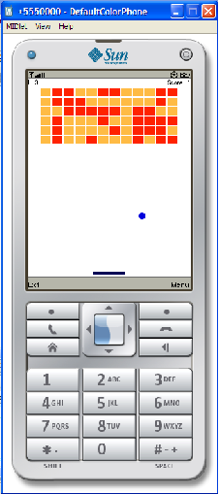
Figure ‎3.11: Breakout-Video Game, developed under Java Netbeans can easily be ported on any mobile (PDA) device.

The goal is to remove all the bricks by hitting the ball to them and the bar at the bottom can be moved to the right or left to avoid sinking the ball from the bottom line which leads to losing one life. The appearance has to be kept as simple as possible to prevent user distraction.

Game Controller
Since the game should support remote control, new control interface has been implemented for it. This interface should be capable of establishing TCP or UDP connection to the game server, beside the ability to control the game. At least three control signals is needed, MOVE_LEFT, MOVE_RIGHT, STOP. While MOVE_LEFT causes the bar starts to go left and MOVE_RIGHT makes the bar to go right, STOP gets the bar stopped.
The very first problem which could affect the game performance is related to continuous control signal. In the other word how the bar should move, it moves constantly to the right or the left till one of the control signals is received, or it should move the certain distance based on the received control signals. The first solution results in less network traffic because one control signal is enough to move the bar from the right to left, however selecting the suitable speed is not an easy job. Besides that, the cost of one missing packet or late packet could be so high. The bar keeps moving to the left while the STOP or MOVE_RIGHT signal has been missed. The other solution only suffers from busy network traffic which could lead in more power consumption. Since at this point we are not concern about power, we decided to develop the game controller based on the second option. A number also has been added to the control signals to indicate how distance the bar should move.
As it is depicted in Figure 3.8, a new layout has been developed to let the player configure network settings, such as server’s IP and Port.
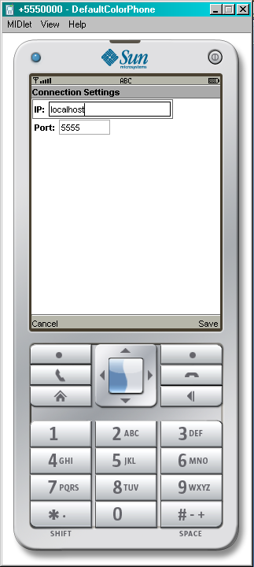
Figure ‎3.12: Connection Settings layout for Breakout game

Implementation
Development of this project breaks into three sections, Bluetooth, Game Server and Breakout game. Each of them has been implemented in different environment with different programming languages. The Bluesense part was developed in C++ while two others were implemented in Java language. In fact the Breakout game which has to be run on mobile phones was implemented in Java Platform, Micro Edition (Java ME) [46]. C++ was selected for Bluesense development because it was supposed to be integrated to BCI2000 acquisition module which has been written in C++ language. Game server could have been developed both in Java or C++ but we have decided to implement it in Java language since we are more familiar with the language.

For Breakout Game, Java ME has been selected using MIDP over CLDC, which is the most common configuration/profile for mobile sets. Since we need low-level network programming (TCP or UDP), MIDP 1.0 is not suitable for this project. The low-level network support has been added to J2ME since MIDP 2.0 [63]. This may cause less number of mobile sets to be able to run our game but for an experimental usage it should not be a big deal. Additionally, most of the new devices support MIDP 2.0. There are a couple of reasons for selecting J2ME as a development language for our mobile game. In the following section we will look into these reasons.

Why J2ME?
- Java Me is portable across the widest range of devices. While other technologies are limited to the specific vendor the J2ME is vastly supported by all vendors.
- Since J2ME is more or less similar to standard Java, its easer for java developer to switch to mobile programming.
- More potential developer, results in more resources being available in the Internet and more companies being encouraged to support java on their handsets. Just by searching J2ME keyword in any popular search engines, the popularity could be seen.
- Nowadays almost all the major phone vendors support java on their handsets, such as Sony-Ericsson, Nokia, and Motorola.
- PDAs are not the same as handsets, and it is more likely to find the PDA without supporting of Java. But this situation is rapidly going to be changed; Palm and IBM announced in July 2003 that ALL Palm Tungsten devices will ship with an integrated Java ME (J2ME) runtime by fall 2003.

Bluesense Driver Development
Borland C++ Builder in MS Windows operating system was used as a development environment. This decision has been made due to BCI2000’s constraints which should be compiled only in Borland C++ version 6 and upper. Bluesense can communicate over the established virtual Serial port, thus knowledge of Serial communication in windows environment is essential to understand how the codes work. Below an introduction to serial programming in windows is discussed.

Serial communication in MS Windows
Serial communication in windows consists of three main functions, opening connection, reading and writing. Opening COM port could be done same as opening file in C++ with some special parameters; one of the important parameter is about Overlapped or Nonoverlapped operation. We will get into the details of Overlapped IO a bit later. After opening a COM port, data might be sent or received to/from the connected device. WriteFile and ReadFile are the two methods that can be used. For setting Serial parameters such as Baudrate, Parity and so on, SetCommState method should be used.
As we mentioned before reading could be done Overlapped (asynchronous) or synchronous, for asynchronous communication which has been selected for this project due to its efficiency, some kind of event mechanism is needed. Fortunately, there is a way to ask the system to notify program when certain events happen. But in Windows it is not as straight forward as other event-driven systems. First we should listen to one specific event using SetCommMask method, then we should wait till this event happens and that could be done by using WaitCommEvent method. The complication is exactly at this point. It looks like a pooling system because we are waiting till something happen and all threads are dead. The solution is overlapped IO. Think of overlapped IO as an asynchronous IO. Whenever a function makes a call and specifies the overlapped IO structure, it means that it is trying to do the current operation but, if it is not able to be completed immediately, let the program know when it is done with this IO. The way the system lets the program know about the completion is by setting a kernel event object that is part of the lpOverlapped structure. So, all should be done is spawn a thread and make the thread wait for that event object using one of the WaitForSingleObject() APIs. For more information, visit [64].

Protocol Implementation
We have designed and implemented the event-driven program to send and receive packet from Bluesense. The program sets a flag for windows API whenever the data is ready to be sent and also it registers an event to be notified whenever the data has been received. In a big view, our code consists of two main methods, one for sending and the other for receiving data. The first challenge was to make sure the packet has been transmitted correctly and the receiver has received the packet. Since, no mechanism is provided in the protocol for secure transmission except acknowledge for each received packet, and also Bluesense does not support sliding-window technique, we have decided to synchronized the sending and receiving, in the other word when a packet is sent, the program will retransmit the packet in a certain timeout till the acknowledgement is received. If retransmission occurs more than a certain times the connection will be closed and error will be reported. Since, the program has been designed event driven; receiving the acknowledgement of the packet must be also an event. To simulate event in C++, the CreateEvent method in windows API has been used and WaitForSingleObject method has been applied to wait till the event is signaled. The SEND method is waiting till the acknowledgment is received or timeout occurs. In the first case the SEND returns true and program is able to send another packet, but in the former case it re-sends the packet and hopes the acknowledgement being received. This mechanism will decrease the performance but since no sliding-window technique is supported by Bluesense, it is unavoidable.

BCI2000 Signal Acquisition Module
BCI2000 has four modules, Source Acquisition, Signal Processing, Application and Operator. In this part, it is only needed to deal with Source Acquisition module. The data provided from EEG is sampled and transferred by BluesenseAD and should be processed by BCI2000. The Source Acquisition in BCI2000 gets the block of data and conveys it to Signal Processing module and Operator controls the entire process. To accomplish integration in BCI2000 some standards should be obeyed, such as how to initialize and tear off connection, how to send data and so forth. In the following paragraphs the most important methods in Signal Acquisition will be more discussed.
- void Preflight( const SignalProperties&, SignalProperties& ) const;
- void Initialize( const SignalProperties&, const SignalProperties& );
- void Halt();
- void Process( const GenericSignal&, GenericSignal& );
The Preflight function will check whether the board works with the parameters requested, and communicate the dimensions of its output signal. So the connection is established at this method.
The actual Initialize function will only be called if Preflight did not report any errors. Thus, any further checks may be skipped and only the data transmission should be started.
The Halt function should stop all asynchronous activity that our ADC code initiates.
The Process will read block of data whenever the data is ready, thus the board driver should have a method to make this function wait till the block of data is ready.

Compatible Driver for BCI2000
BCI2000 needs the device driver supports at least three functions, start data acquisition, stop data acquisition and wait till the block of data is ready. Since the Bluesense protocol has been developed from scratch, the driver should be developed as well. The Bluesense protocol program is able to setup connection, disconnect, start and stop data acquisition. But no method for reading Block of data is included in this file. The program gets the data and stores them in the buffer, the challenges are when and how to read from this buffer. Since the data are coming continuously, reading data from buffer should be synchronized with writing data in buffer. To provide synchronized reading, MUTEX (Mutual exclusion) in windows API was used [65]. In the writing method any received data are added at the end of buffer and when the data reach to the block size the reader method is notified about that, this solved the first problem of when to read. In addition, when the read method starts reading, writing in the buffer will be blocked to achieve synchronized reading and this solved the second problem of how to read. Beside these reading and writing method we implemented two other method to notify Bluesense to start or stop sending packet.

How Bluesense Driver works
In this section, the implemented codes will be explored in details. The fundamental knowledge has been already discussed in the previous sections, thus we will just go through the codes and we will explain the logic of the program.

BluesenseAD
This class is developed for BCI2000 acquisition module. Figure 4.1 shows some of the important methods of this class. Preflight creates the serial connection to the desired COM port using the connect_bluesense method from “BSController” class. Initialize method starts the Bluesense device to send sampled data; this method is also using another function of “BSController” class. Halt stops the Bluesense board sending more data.

void BluesenseAD::Preflight( const SignalProperties&,
SignalProperties& outputProperties ) const{
connect_bluesense (comPort.c_str (), tBaudRate, Parameter (“SamplingRate”), parameter (“SourceCh”), SERIAL_PARITY_NONE, 8, false))
}
void BluesenseAD::Initialize (const SignalProperties&, const SignalProperties&){
start_bluesense_sampling();
}
void BluesenseAD::Halt(){
stop_bluesense_sampling ();
}
void BluesenseAD::Process (const GenericSignal&, GenericSignal& outputSignal){
wait_for_data_block (buffer, mSampleBlockSize);
for (int channel = 0; channel < mSourceCh; ++channel)
for (int sample = 0; sample < mSampleBlockSize; ++sample)
outputSignal (channel, sample) = buffer [channel][sample ];
}
Figure ‎4.13: BluesenseAD Schematic Source Code

Process is the most significant method in this class. It is responsible to get the block of data and pass it to the next module (Signal Processing). First, it makes sure that the block of data is ready which is done by the first line of the code, and then it loops over the entire blocks and channels and reads the data from the buffer and passes them to the output signal.

BSController
This class was developed as a compatible driver for BCI2000. It wraps some of the Bluesense Protocol class and provides functions which can be used in BCI2000’s acquisition signal module. The purpose of this class is to enhance the codes’ modularity; otherwise these functionalities could be implemented in the main class (BluesenseAD.cpp). This section will be started with an overview of the class and will be continued with explanation of functionalities of each method. Figure 4.2 shows the overview of this class. The first three methods are internal methods which are used only by other methods of this class. The others provide the mechanism for BCI2000’s acquisition signal module class (BluesenseAD.cpp) to access Bluesense Protocol class which will be discussed later.

void OnDataArrival(int size, char *buffer)
void SerialEventManager(t_uint32 object, t_uint32 event)
bool sendDataWaitForConfirm(Tserial_event *com, unsigned char * packet, int size)
int connect_bluesense (const char *port, int rate, int sample_rate, int no_of_channels, int parity, char ByteSize, bool modem_events);
int disconnect_bluesense();
int start_bluesense_sampling();
int stop_bluesense_sampling();
int wait_for_data_block(short buffer[MAX_CHANNEL][MAX_BUFFER_SIZE],int block_size);
Figure ‎4.14: Overview of the Bluesense controller class

OnDataArrival handles the received data through virtual serial connection. The layer underneath of this class is a utility class which handles all Serial Communications in windows environment which will be explained later. The serial handler class provides the mechanism to upper layer class to register different event on the open serial port to be notified whenever that specific event happened. This registration is done in SerialEventManager method. Furthermore, this method calls OnDataArrival whenever the data is received from serial port. Figure 4.3 shows schematic codes for SerialEventManager method. The serial handler class provides different events that upper layer classes can use them to listen for different event. As it can be seen, on the SERIAL_DATA_ARRIVAL event, the program calls OnDataArrival method to notify the program about received data.

void SerialEventManager(t_uint32 object, t_uint32 event){
switch(event) {
case SERIAL_CONNECTED :
//printf("Connected ! \n");
break;
case SERIAL_DISCONNECTED :
printf("Disonnected ! \n");
break;
case SERIAL_DATA_SENT :
//printf("Data sent ! \n");
break;
case SERIAL_RING :
printf("DRING ! \n");
break;
case SERIAL_CD_ON :
printf("Carrier Detected ! \n");
break;
case SERIAL_CD_OFF :
printf("No more carrier ! \n");
break;
case SERIAL_DATA_ARRIVAL :
size = com->getDataInSize();
buffer = com->getDataInBuffer();
OnDataArrival(size, buffer);
com->dataHasBeenRead();
break;
}
}
Figure ‎4.15: SerialEventManager schematic source code

Figure 4.4 presents the pseudo code for OnDataArrival method. This method reads data from the buffer and recognizes the Bluesense packet from the start and end flag and sends them to Bluesense protocol class for further processes. It does not have any idea about the meaning of the packets or checksum correctness. It only extracts the packet from the sequential buffer.

void OnDataArrival(int size, char *buffer){
///Extract Packet
for (h=0; h < size; h++){
recieved_packet[recieved_packet_size + h] = (unsigned char) buffer[h];
recieved_packet_size ++;
if ((unsigned char) buffer[h] == END_FLAG){
end_flag_rcved = true;
}
}
if (end_flag_rcved){
WaitForSingleObject(ghMutex,INFINITE); //exclusivly add to buffer block
switch (handle_rcved_packet(recieved_packet, &recieved_packet_size)){
case 6315: //data packet
sample_data = read_data();
data_size = read_data_size();
data_has_been_read();

//data is ready to be sent as a block!
if ( current_data_size > g_block_size ){
SetEvent(block_is_ready_event);
}

SetEvent(packet_rcved_Event);
break;
default:
SetEvent(packet_rcved_Event);
break;
ReleaseMutex(ghMutex);
}
}
Figure ‎4.16: pseudo code for OnDataArrival method

To understand what this method does it is needed to go through all the lines and explain the method line by line. The first block is easy to figure out; it loops over the received data and specifies when the END_FLAG is reached. Usually this method is called for each single received byte, but if the performance degrades due to this fact, it could be change to be called based on more bytes of data. Then it is necessary to take care of the deadlock situations, for example the END_FALG can be the first byte of the next chunk of data. The program is waiting for the next packet and the serial handler is waiting till the block of data is getting ready, which leads to the deadlock. Anyway, when the END_FLAG is reached, the program can go inside the second block. In the first line, the Mutex is used to guarantee the exclusive access to the shared buffer [65]. Shared buffer is the actual sampled data which are being used in the wait_for_data_block method. In this block the data is read and stored in shared buffer while wait_for_data_block method further reads them and sends them to the BCI2000 interface. But how does OnDataArrival method find out that this received packet is the data packet and not signaling packet? The answer is simple, in the Switch block, handle_rcved_packet method is a public method of Bluesense protocol class. It knows about the different protocols packet and also it is able to parse the packets and extract the useful information out of them. If the received packet contains data then it returns “6315”. Thus, it is determined that the packet contained data, and those data and their size can be further read by calling read_data and read_data_size. The lower layer is also notified by calling data_has_been_read to let it know that the data has been read and the resources can be released.
The rest of the code is about the event management. When the block of data is ready for BCI2000 interface the wait_for_data_block method should be notified which is done by signaling the event block_is_ready_event. Additionally, there is another event that should be signaled on any valid received packet to notify the sendDataWaitForConfirm method that the new confirmation packet has been received so it does not need to retransmit the packet.
As we discussed in section (4.1.2 Protocol Implementation), the Bluesense does not support any mechanism to avoid packet loss except sequential packet number confirmation. Since successfulness of one job depends on the previous one, the driver should wait till the acknowledgment from the Bluesense is received. This functionality has been implemented in sendDataWaitForConfirm method. It simply waits for each sent packet until the confirmation is received. Retransmission has been also handled in this method, certain number of retransmission occurs before the connection is asked to be torn off.
connect_bluesense provides the easy way for BCI2000 interface to establish serial connection to Bluesense while disconnect_bluesense is responsible to tear off the connection safely. They use Bluesense protocol class functions to manage their tasks. They also maintain some global variables to let the other methods use them for sending and receiving data over this connection. Since their codes are obvious, there is no need to figure them out in more details.
start_bluesense_sampling orders the Bluesense chip to start transferring sampled data and stop_bluesense_sampling makes the chip to stop sampling however they do not have any effects on connection status. These methods use the established connection which has been setup in connect_bluesense method to send the signaling packets to Bluesense device. Since the code is straight forward, there is no need for further pseudo code depiction. The only important issue that we should take to our consideration is the mechanism for buffering data. Since data are flooding from Bluesense and temporary the processing speed might be less than receiving speed, a buffer mechanism is essential. Circular Buffer has been used to make sure none of the packets will be lost, the alternative approach can be Double Buffering technique in which only two blocks of data could be buffered at the same time, in the other word while the data is being written in one buffer the reader can read data from the other buffer, but this solution suffers from the temporary buffer overflow. In our solution data is buffered till the entire buffer gets full and the buffer size is usually several times bigger than block size. Congestion control technique can also be applied simpler in this type of buffering. Since BCI2000 works with blocks of data, it should be notified only when the block of data is ready and not on each data arrival. wait_for_data_block is developed to be used by BCI2000 interface. This method makes the thread wait till the block of data is ready to be read. Figure 4.5 illustrates the source code of this method. At the beginning of this method, the size of the current received data is checked and if it is bigger than requested block size there is no need to wait, so the status can be set to WAIT_OBJECT_0 which leads the process get into the condition block. But if the data is not enough to fill one block then the process is kept on hold by WaitForSingleObject method from Win32 API on the block_is_ready_event event which later may be signaled by OnDataArrival method when enough data is received.

int wait_for_data_block(short buffer[MAX_CHANNEL][MAX_BUFFER_SIZE],int block_size){
long status = 0;
//there is no problem to check buffer size without synchronization,
//because it may only get bigger and deadlock won’t happen and data is available to be read
int current_data_size = channel_end_index[0] - channel_start_index[0];
if ( current_data_size < 0 ){
current_data_size = MAX_BUFFER_SIZE + current_data_size;
}
if ( current_data_size > g_block_size ){
//this may not be the best way, but it’s easiest!
//by setting status to this value this method will not wait because the block is ready :)
status = WAIT_OBJECT_0;
}else {
// we should wait cuz the block is not ready yet!!
status = WaitForSingleObject(block_is_ready_event,INFINITE);
}
if ( status == WAIT_OBJECT_0){
WaitForSingleObject(ghMutex,INFINITE); //exclusivly read block
///always data is available we should not worry about the circular array!!!
for (int i=0;i < g_no_of_channels;i++){
int start_indx = channel_start_index[i];
for (int j=0;j < block_size;j++){
buffer[i][j] = channel_sample[i][start_indx]-2047;
start_indx++;
if (start_indx == MAX_BUFFER_SIZE){
start_indx = 0;
}
}
channel_start_index[i] = start_indx;
}
ReleaseMutex(ghMutex);
}
return 1;
}
Figure ‎4.17: Source code of wait_for_data_block method

In the condition block, the circular buffer cannot be read without satisfying the exclusion access which is done by Mutex mechanism in Win32 API [65]. Therefore, we can make sure that the buffer cannot be accessed at the same time and either reading or writing from/to the buffer but not both can be performed simultaneously. The rest of the code in for loops is about reading from the Circular Buffer and filling the BCI2000’s block which is also a buffer.

BSProtocol
This class only knows about the BluesenseAD packets format. Other classes usually use it to get their received packets parsed or just get the Bluesense compatible packets. Bluesense controller is not involved in any logical tasks. It does not know anything about sequence of connection setup or start sampling commands. In Figure 4.6, all the methods of this class are shown. Most of the functions just return the packet which is compatible for Bluesense. It is up to the user class to decide how to use these packets. For example the BSController class uses these packets to setup the connection to Bluesense, and it knows the logic to do that.

// 5.2.21 CS_WRITE_UART_BAUD_RATE_REQ
unsigned char* CS_WRITE_UART_BAUD_RATE_REQ (unsigned char pak_n, int baud_r, int *size)
// 5.2.22 CS_WRITE_UART_BAUD_RATE_CFM
unsigned short CS_WRITE_UART_BAUD_RATE_CFM (unsigned char* packet, int *size)
// 5.2.35 CS_INIT_BLUESENSEAT_REQ
// reinitialize BluesenseAT via software
unsigned char* CS_INIT_BLUESENSEAT_REQ(unsigned char pak_n, int *size)
// 6.3.3 Establishment of a SPP to analog channel
unsigned char* CS_SPP_START_ANALOG_REQ (unsigned char pak_n, unsigned char BT_address[8], unsigned char server_CH[2], int *size)
// 6.3.4 Confirm the connection establishment
unsigned short CS_SPP_START_ANALOG_CFM (unsigned char* packet, int *size)
// 6.3.5 choose between the different function mode
unsigned char* CS_SET_FUNCTION_MODE_REQ (unsigned char pak_n ,unsigned char mode, int *size)
// 6.3.6 Confirm
unsigned short CS_SET_FUNCTION_MODE_CFM (unsigned char* packet, int *size)
// 6.3.7 Configuration of the AD converter
unsigned char* CS_CONFIG_ADC_REQ (unsigned char pak_n ,int sample_rate,unsigned char no_of_channels, int *size)
// 6.3.8 Confirm of the ADC configuration
unsigned short CS_CONFIG_ADC_CFM (unsigned char* packet, int *size)
// 6.3.9 starting and stopping of the sampling
unsigned char* CS_START_STOP_ADC_REQ (unsigned char pak_n ,unsigned char start_or_stop, int *size)
// 6.3.10 Confirmation of ADC started or stopped
unsigned short CS_START_STOP_ADC_CFM (unsigned char* packet, int *size)
// 6.3.15 Packet with sample value
unsigned short CS_ADC_DATA (unsigned char* packet, int *size)

unsigned short int update_crc(unsigned int crc, unsigned char c)
unsigned char* OCTET_STUFFING(unsigned char* origPack, int *size)
unsigned char* UNDO_OCTET_STUFFING(unsigned char* origPack, int *size)
short int* read_data()
short int read_data_size()
void data_has_been_read()
// 4.1.3 Cpmmand Reject
unsigned short COMMAND_REJECT (unsigned char* packet, int *size)
unsigned short handle_rcved_packet(unsigned char* rcved_packet, int *size)
Figure ‎4.18: BSProtocol class. No logic is implemented here and only compatible packets are generated by these methods.

The sequence of packets that should be sent to Bluesense to perform a specific task has been already explored in the previous sections. The method names have been kept the same as ones in Bluesense datasheet for easier tracking. The methods that return “char*” actually return the packet for that command. And methods that return “short” check the correctness of received confirmation from Bluesense and return the number corresponding to the command number in Bluesense datasheet. The last 8 methods in Figure 4.6 are utility functions that are used both inside and outside the class. update_crc calculates the CRC checksum for the packets. OCTET_STUFFING method changes the special characters in the packet such as START_FLAG to make it readable for Bluesense device. UNDO_OCTET_STUFFING applies over the received packet to undo octet stuffing that has been done in Bluesense microcontroller. read_data, read_data_size and data_has_been_read are used by the caller class to read the value of received data. COMMAND_REJECT is called whenever the packet cannot be processed by this class so further decision can be implemented in this method. handle_rcved_packet parses the received packet and returns the value that indicates the type of received packet, for example “6315” indicates that the packet is a data packet.

Tserial_event
This class is the lowest layer in Bluesense Driver. It is an open source class that can be used as a serial communication manager in Windows environment. It is responsible for handling serial communication in Win32. As we discussed before it applies Overlapped I/O mechanism. It defines all the events related to Serial Communication (RS232) and handles them in an infinitive loop. In the other word, it waits until one of the known events happen then based on the signaled event it decides what to do. For example if SIG_DATA_TO_TX event is signaled, this class will write the buffer to the output. There is couple of public methods that the user of this class may call to manage sending and receiving data over serial port. Figure 4.7 shows the most important methods of this class.

int connect (const char *port, int rate, int parity, char ByteSize, bool modem_events);
void setManager (type_myCallBack manager);
void setRxSize (int size);
void sendData (char *buffer, int size);
int getDataInSize (void);
char * getDataInBuffer (void);
void dataHasBeenRead (void);
void disconnect (void);
Figure ‎4.19: Tserial_event class. Only public methods of this class are shown in this figure.

connect method establishes the serial connection on the desired port with the specified settings. setManager lets the upper layer classes to register a listener in order to be notified whenever any event happens. setRxSize defines the size of the reading buffer. sendData sends the specified char array via the established connection. getDataInSize returns the size of the data that has been read. getDataInBuffer returns the received data. dataHasBeenRead should be called to allow this class release recourses. disconnect method disconnects the established connection safely.

Breakout, Video Game, Development
Mobile programming is quite different from application programming. Since the development environment completely differs from the running environment, some sort of simulator is necessary. Some companies like NOKIA provide SDKs to preview messaging content in the specific device simulators. But that is useful when the target devices are NOKIA handsets. For experimental purposes, we found the Sun Emulator Toolkits [66] the best option. For development NetBeans IDE 6.0 [67] has been selected, which includes “Visual Mobile Development” as well. By using Visual Mobile Development, GUI applications that run on mobile phones, set-top boxes, and PDAs could be created, tested and debugged. Before we discuss about the codes, it is necessary to mention some important issues in J2ME such as network programming.

J2ME Network Programming
Making connection in Java ME is different from standard java and it is more abstract. The Generic Connection Framework provides a single set of related abstractions you can use at the programming level to handle multiple forms of communications, instead of using different abstractions for different protocols. In Generic Connection Framework, all connections are created using the open static method of the Connector class. If successful, this method returns an object that implements one of the generic connection interfaces. The general schema is like below:
Connector.open("protocol:address;parameters");
A few examples:
- HTTP Connection: Connector.open(http://ip/);
- Socket Connection: Connector.open("socket://ip:port");
- Datagram Connection: Connector.open("datagram://ip:port");
It should be noticed that MIDP 2.0 implementers must provide support for HTTP 1.1 servers as well as secure HTTP connections. They should also provide support for low-level IP networking, but this decision is left to the handset manufacturers and network operators. For instance, as it will be mentioned later, the PDA we used in this project supports TCP/IP but not UDP/IP.

Breakout using TCP Connection
To establish the TCP connection, a client should send a request to the server. Server is the side that listening continuously for the incoming request on the specific IP and PORT number. To open a inbound server socket on a specific port in Java ME Connector.open("socket://:port"); should be used. In the example below a server socket stream connection will be opened on the port 4444.
Connector.open("socket://:4444");

In our client/server design, the game on the mobile set is a client and the PC running the Game Server is considered as a server. Thus, server socket in Java ME is not necessary. On the other hand, client side networking is needed to be done in J2ME, which is challenging. Since, the processing power and memory capabilities of the mobile sets are so short, the programming should be done in double supervision. Small number of concurrent threads and deadlock avoidance besides maintaining the high throughput are the most challenging issues.
We designed the client network with only two threads: one thread for establishing connection and receiving data, the other thread for sending data. Since sending is rarely happen for the game, the sending thread most of the time is kept sleeping and only when a packet is ready to be sent the thread will be notified. In the other word, only one thread is alive and continuously listening for incoming packets. The client socket could be opened by using Connector.open("socket://" + hostname + ":" + port); method. Where the “hostname” is the IP address of the server and the “port” is the open port on the server.
Once the connection has been setup, both server and client can send and receive data over the established connection. In this game, mostly the control signals are being flooded from the server to the mobile.

Breakout using UDP Connection
There are not many differences in TCP and UDP model, the main issue is UDP is not connection oriented like TCP and also is not reliable. But in the game controlling which is real-time controlling, the reliability is not an issue, only the performance and speed is important.
We made changes in client side (Mobile) to listen on a port to receive datagram packets and also we changed the server to listen on the port for receiving datagram packets too. Client sends the packets to the server, so the client should know about the server’s IP and PORT number, but the server will reply to the IP and PORT number which are indicated in the received packet. The networking will always start by the client request and then the server starts to flood the control signals to the client. Below the way to open server UDP is depicted:
Server: Connector.open("datagram://localhost:" + port);
The program will be listening to the “localhost” interface on the specified port. For sending datagram packet no more connection is needed to be opened. Only a datagram packet with the IP address and PORT number of the other side should be constructed and be sent through the existing UDP interface.

Breakout Implementation
We have adapted the popular Breakout game to a simpler version, more appropriate for the BCI task. Bricks have been removed to reduce the nondeterministic matter of ball landing point but still it had a kind of strategy and it might result in failure due to the bouncing ball. In a beginner’s mode, a green bar at the bottom has been added to indicate the landing point of the Ball, so the user should not think about anything else except moving the bar to the target. In an expert mode this green bar is eliminated. In Figure 4.8 the picture of the new Breakout layout is depicted running within the emulator. The game was tested using an HTC phone running Windows Mobile 5, and in a HP PDA hx2400.

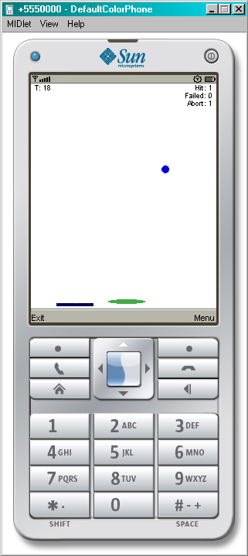
Figure ‎4.20: Breakout, Video Game, developed under Java Netbeans can easily be ported on any mobile (PDA) device.

The goal is to avoid ball sinking. Each catch is considered as a Hit and each sink as a Failed. Abort is the situation when too many wrong orders happen, for example when the indicator (green bar) is at the left of a bar, the bar should be moved to the right, but if the bar is moved to the left then it is considered as an Abort.
We will not explain how the game codes work since it is out of the scope of this project. However the part of the code that is related to game controlling and network connection will be discussed in detail.

TCPConnectionForm
This class generates a form including all the options for setting a TCP connection to the game server. The most important subclass of Screen is the class Form. A Form can hold any number of Items such as StringItems, TextFields, and ChoiceGroups. Items can be added to the Form using the append() method. We will not get into the MIDlets concept in J2ME programming, this book [68] can be used as an reference for J2ME programming. Figure 4.9 shows the singleton design of TCPConnectionForm. Its constructor is defined private to avoid multiple instantiations of this class in application. Any other classes need to access this object can use getConnectionForm method to get a singleton object of this class. In the private constructor entire items such as, input box for IP address and port number, are appended to this form. This class also implements CommandListener interface which allows listening for command events and performing the desired action based on these events. commandAction method is responsible to handle command events.

public class TCPConnectionForm implements CommandListener{
private TCPConnectionForm(Display display,Canvas backCon){
//appends items to the form
}

public void commandAction(Command command, Displayable displayable) {
//handles command actions
}

public static TCPConnectionForm getConnectionForm(Display display,Canvas backCon) {
//returns singleton connection form
}

public Form getForm() {
//returns the actual Form
}

public TCPConnectionManager getConMan() {
//returns Coresponding connection manager
}

public Canvas getBackPage() {
// returns the parent page
}
}
Figure ‎4.21: Singleton TCPConnectionFrom class. This object cannot be instantiated, only can be access via getConnectionForm method.

As we mentioned before this class has been designed singleton. The static public getConnectionForm method provides other classes with single object of this class. It ensures that the return object is only one (singleton). For some reasons it is needed to have access to the original MIDP From, the getForm method retunes the actual Form that is associated with this object. There is no logic of network programming in this class, and it has been kept as simple as possible. The actual network programming has been done in other classes and TCPConnectionManager manages the whole process. This form which has been developed only for visualization in mobile environment is associated with one connection manager. This connection manager can be achieved by getConMan method. In MIDP, only one layout or form can be viewed at the time, and user jumps from one page to another. This form can be accessed through different workflow which makes the decision for going back to the parent page difficult. Whenever this form is called the caller sets itself as a parent page into this form, thus the workflow can go back to the parent page after settings are done. This parent page or back page can be resolved from getBackPage method.

TCPConnectionManager
This class manages the TCP connection. It establishes TCP connection and sends and receives packets to/from game server. It also implements Runnable interface to provide new thread running concurrently with the game. The code for receiving packet has been embedded inside this class while sending should be done through another class (TCPSender). Since sending packet is occurred rarely but concurrently with receiving in this application, we design a separate thread for sending which will be discussed in the next section. Figure 4.10 shows the interface of this class; notice how the Runnable interface is implemented in class definition line. The constructor of this class gets the values needed for establishing connection to the game server from connection settings form as arguments and keeps them globally in the class. The first two methods (getPortNo and getIpAddress) simply return the server’s port number and IP address. start() method makes a new thread from this Runnable class and makes it run. Respectively, stop() method stops the thread, closes all the connections and releases all the recourses.

public class TCPConnectionManager implements Runnable{

public TCPConnectionManager(Display d,TCPConnectionForm conFrm,String ipAddress, int portNo){
}
public int getPortNo() {
}
public String getIpAddress() {
}
public void start() {
}
public void stop() {
}
public void run() {
sc = (SocketConnection) Connector.open("socket://"+ipAddress+":"
+ portString);
is = sc.openInputStream();
os = sc.openOutputStream();

// Start the thread for sending messages - see Sender's main
sender = new TCPSender(os);

// Loop forever, receiving data
while (true) {
GameController.performAction(sb.toString());
}
}
}
Figure ‎4.22: TCPConnectionManager class including all its methods and the pseudo code for receiving packet.

Runnable interface has an abstract method (called run) which should be implemented by its implementers and would be run as a thread whenever the class is called as a thread in the application. The code regarding to sending and receiving data has been written in this method. At the first line the TCP connection is opened using specified IP address and port number. The streams related to input and output are acquired in the following lines. The management of sending packet is delegated to another thread called TCPSender. The most important part is an infinitive loop where the packet is received and transferred to GameController class for further decision. This loop can be terminated explicitly by calling stop method otherwise it will be listening for incoming packet forever!

TCPSender
As it was mentioned before, sending data is handled in another class. TCPSender extends the Thread class and overrides Thread’s run method to handle sending data in the new thread. Since running thread takes resources and mobile phones usually have small capabilities beside the fact that sending occurs rarely in this application, we decided to make this thread sleep till some data are necessary to be sent. The TCP manager class signals this class and passes the data which will be further transferred over the established TCP connection. Figure 4.11 shows the list of TCPSender’s methods. In its constructor, it gets the output stream as an argument and keeps it as a global variable; in the next step it gets the new thread started which will be waited till the send method is called. This mechanism is implemented by using notify and wait methods of J2ME API which has been coded inside send and run methods.

public class TCPSender extends Thread {
public TCPSender(OutputStream os) {
}
public synchronized void send(String msg) {
notify();
}
public synchronized void run() {
while (true) {
wait();
os.write(message.getBytes());
}
}
public synchronized void stop() {
}
}
Figure ‎4.23: TCPSender class including all its methods

send method gets the String value (message) as an arguments and stores it globally in the class and later by notifying the thread, causes the thread to send this message. Sending is actually happens in run method. It sends the desired message through the global output stream variable and then goes to sleep in the next iteration of the while loop. stop method basically stops this thread and does not have any effect on the TCP connection. All methods of this class are declared synchronized which ensures one message can be send at the time, which means while one message is being sent the next sending request will be kept on hold till current transmission gets over.

Protocol
This class contains the entire meaningful messages that can be interpreted by both side of the connection, game controller and game server. One copy is kept in client side and one copy at server side, thus both sides can understand their communication language. By keeping the protocol in a separate class, the code can be maintained much easier. One can define new message in both client and server protocol class without changing any logic inside the application.

GameController
The game was originally developed to be played through the phone’s keypad. We did not want to eliminate this functionality from the application instead we were intending to augment the game with the remote control functionality. This class has been implemented to be an interface between network messages and original game controller. Since the code is straightforward we will not depict it in this report. It has a static method that gets the received message as an argument and interprets it using Protocol class and then controls the game based on the interpreted message. For example if the received packet is about moving 10 unit to the right, it moves the bar 10 unit to the right.

UDPConnectionForm, UDPConnectionManager, UDPSender
These classes work exactly the same as corresponding TCP ones except they use UDP as a link to send and receive game’s data. Since their codes are identical to TCP ones, we are not going to get into their implementations. Only the minor differences will be mentioned for complementary.
- UDPConnectionForm provides one more field in layout for local port indication. UDP needs to know the server port and IP and also the local port for receiving datagram. This port can be selected randomly by the application but we decided to let the user to peek any desired port.
- UDPConnectionManager has the same structure as TCPConnectionManager but of course it uses the UDP for receiving datagram from the game server. In order to do that it opens the datagram connection (like below) on the specified local port and waits for receiving data.
Connector.open("datagram://localhost:" + localPortString);
The issue here is how the server knows to send the packet to device’s IP address and port. To solve this problem, the hello packet is sent to the server using the device’s IP address and port as a source IP and port in datagram. Once the server receives the datagram, it extracts the source IP and port and keeps them for further communication to game application.
- UDPSender is completely the same as TCPSender except the send method which accepts two arguments instead of one. It gets both address and message and delivers the datagram to the specified address. Since UDP is connectionless, the address of the server should be specified.

Game Server Development
BCI2000 provides a way to send and receive both output signals for controlling output device and system parameters for updating application status via UDP. Since the PDA or mobile phone may not support UDP and also the protocol implementation should be kept as simple as possible, we decided to implement an intermediate application which is able to get the UDP datagram from BCI2000 application connector and interprets them and further communicates with game via TCP or UDP using our designed protocol. A gaming server application with above specifications has been created using Java NetBeans IDE 6.0 technology running under the Windows-XP environment. Java Platform, Standard Edition (Java SE) which is suitable for developing Java application on desktops and servers was used as an implementing language.

Network Programming in Standard Java (Java SE)
Network programming at transparent layer in Java language falls into two parts; TCP and UDP. While TCP is a connection oriented protocol that provides a reliable flow of data between two computers, UDP is a connection less protocol which sends independent packets of data, called datagram, from one computer to another with no guarantees about arrival.
Through the classes in java.net, Java programs can use TCP or UDP to communicate over the Internet. The URL, URLConnection, Socket, and ServerSocket classes all use TCP to communicate over the network. The DatagramPacket and DatagramSocket, classes are for use with UDP.

TCP Programming
Client side TCP programming is straightforward. It uses socket for making connection to the server. The steps for handling client socket can be summarized in:

- Open a socket. testSocket = new Socket(hostName, portNumber);
- Open an input stream and output stream to the socket.
out = new PrintWriter(testSocket.getOutputStream(), true);
in = new BufferedReader (new InputStreamReader( testSocket.getInputStream()));)
- Read from and write to the stream according to the server's protocol.
out.println(userInput);
in.readLine();
- Close the streams. out.close(); in.close();
- Close the socket. testSocket.close();

On the other hand, server side programming is quite different. ServerSocket should be used to let the server listen on the specific port for any incoming connection. Once the request is received from client and the connection is accepted the procedures for reading and writing are the same as client side. The statement below can be used for making server socket on port “4444”.
serverSocket = new ServerSocket(4444);
When the request has been accepted the client socket can be acquired from the server socket like below:
clientSocket = serverSocket.accept();
Further procedures are the same as client side.

UDP Programming
Sending a datagram on the network does not require any connection setup. It can be constructed and be sent over any network interface of the system. Datagram can be constructed as shown in the statement below:
DatagramPacket packet = new DatagramPacket(buf, buf.length, address, 4445);
Where the buf is the client- specific message needed to be sent, address indicates the receiver address and “4445” is the port number of UDP server. This packet can be sent over the datagram socket. The following codes show the way of creating datagram socket and sending packet via it.
DatagramSocket socket = new DatagramSocket();
socket.send(packet);
As it was mentioned client side is simple due to the fact that UDP is connection less protocol.
Now we will get into the server side. First of all we should tell the machine to listen on the specific port; therefore the datagrams can be received on this port. This could be done by creating datagram socket on the specific port:
DatagramSocket socket = new DatagramSocket(4445);
It makes the computer to listen on port “4445” for any incoming datagram. The only thing is left is reading the received data. Again DatagramPacket can be used to read the data. First DatagramPacket should be created and then be passed to the socket through its “receive” method. The statements below show the way of doing this:
DatagramPacket packet = new DatagramPacket(buf, buf.length);
socket.receive(packet);
The DatagramPacket will be used to receive a datagram from the socket because of the constructor used to create it. This constructor requires only two arguments: a byte array that contains client-specific data and the length of the byte array. The last statement in the previous code receives a datagram from the socket (the information received from the client gets copied into the packet). The “receive” method waits forever until a packet is received. If no packet is received, the server makes no further progress and just waits.

Game Server Implementation
A Java desktop application was implemented to serve as an intermediate application between BCI2000 and Video Game. Figure 4.12 shows the game server application after and before connection establishment to the video game.

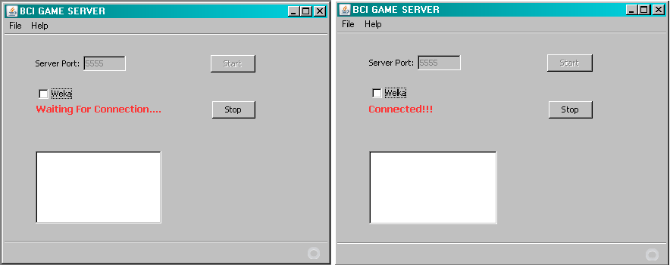
Figure ‎4.24: Game Server application layout before and after connection setup with the video game

By clicking the Start button, the server begins to listen on the specified port for any incoming connection and by clicking on the Stop button the server will stop receiving any more connection. In order to evaluate the connection between Game Server and the Video Game without using BCI2000, the application is implemented in the way that can send control signals based on the keyboard events. Thus, the white area gives the user an opportunity to type in order to control the game remotely but obviously it would be possible only after the successful connection set up.
Since the BCI2000 connector interface can be configured for any input and output UDP port, those settings are hard coded inside the application. “5000” is reserved for incoming messages from BCI2000 and “5001” for sending messages to BCI2000. In the current implementation, it is assumed that the game server will be running in the same computer as BCI2000; therefore there is no need to acquire BCI2000 connector application’s IP address as an input. Later if the game server is wanted to be moved to another system, the IP address of the BCI2000 can be extracted from the first received packet from BCI2000 connector interface. However the address of game server should be set in the BCI2000 application interface. As we know basically how this application works, we can go one level deeper and talk about different classes. The layout implementation is out of the scope of this project and will not be discussed in further details.

UDPBCIApp
As we mentioned before, the Game Server has two interfaces, one is responsible to establish connection to mobile game and the other to send and receive datagram to/from BCI2000. UDPBCIApp class is responsible for communication with BCI2000’s connector application. It knows the BCI2000 protocols and also is able to interpret the control signals, for example if the control signal is moving left or right. Figure 4.13 shows the interface of this class including some schematic codes. It implements Runnable interface in order to be run as a new Thread. The first three variables are defined globally containing the values regarding local UDP port and BCI2000’s IP and port address.

public class UDPBCIApp implements Runnable {
private int localPort = 5000;
private int bciPort = 5001;
private String bciAddress = "localhost";
public boolean isStopped()
public void stop()
public void run() {
socket = new DatagramSocket(localPort);
sender = new UDPSender(socket);
sender.send(bciSocketAddress, Running+"\r");
while (!stop) {
socket.receive(packet);
processPacket(packet);
}
}
private synchronized void processPacket( DatagramPacket packet)
}
Figure ‎4.25: UDPBCIApp class, including all its method and some pseudo code

isStopped returns true if the server has been stopped or false if the server is running. stop method kills the thread and also stops sending or receiving any further packets. run method is the main method of this class which receives the datagram and passes them to processPacket method to be processed. It also creates UDPSender object which can be used for sending UDP packet to the BCI2000 application. processPacket method is an internal function that knows about the BCI2000 packet formats and can extract information out of them. Base on the received packet, processPacket method decides what should be done next. For example, if it is related to game controlling it calls an appropriate method of GameControl class. We will discuss about GameControl class later on this report.

UDPSender
We will not get into its implementation due to its similarity to UDPSender in Breakout Game. We explained completely how the UDPSender works in that section. The only difference is the developing environment. In Breakout, J2ME was used as an implementing language while here (Java SE) was used. In standard Java handling UDP is quite different from mobile Java; however the logic of the class is exactly the same.

Protocol
This class contains the entire meaningful messages that can be interpreted by both side of the connection, game controller and game server. One copy is kept in client side and one copy at server side, thus both sides can understand their communication language. By keeping the protocol in a separate class, the code can be maintained much easier. One can define new message in both client and server protocol class without changing any logic inside the application.

GameControl
Video game on the other side of the connection works based on the control signals generated on BCI2000 application. After they go through the Game Server, they are changed to the common language which can be understood by both sides. This common language is defined in Protocol class. But the way to use this language is not defined anywhere, so GameControl interface has been developed to indicate the basic functionalities that are needed for game controlling. Other classes that want to control the game can implement this interface and all its methods to handle game controlling. The processPacket method in UDPBCIApp class calls the method of this interface to control the Video Game. It is up to the implementer to determine how it works. Figure 4.14 illustrates this interface; all the methods are abstract and have to be implemented.

public interface GameControl {
public void gameControl_moveLeft();
public void gameControl_moveRight();
public void gameControl_stopMoveLeft();
public void gameControl_stopMoveRight();
public void gameControl_fire();
public void gameControl_pause();
public void gameControl_start();
public void gameControl_moveLeft(int dis);
public void gameControl_moveRight(int dis);
}
Figure ‎4.26: GameControl interface, other classes have to implement all these methods in order to be able to control the game.

gameControl_moveLeft requests the game to move the bar to the left continuously. gameControl_moveRight requests the game to move the bar to the right continuously. gameControl_stopMoveLeft and gameControl_stopMoveRight request the game to stop moving the bar to the left or right respectively. gameControl_fire, gameControl_pause and gameControl_start are the controlling signals which usually are not generated by BCI2000 so there is no need to be implemented. Anyway, they are declared here for completeness. gameControl_moveLeft(int dis) and gameControl_moveRight(int dis) are two methods that mostly used. They request the game to move the bar to the left or right the certain distance which can be passed as an argument to the method.

TCPServer
The Game Server gets the packet from BCI2000 and sends them to the video game. The side that communicates with the game has both capabilities to communicate over TCP or UDP. TCPServer has been implemented to let the server establish TCP connection to the game and send/receive packets to/from the game. It implements Runnable in order to be run as a new Thread and also since it is intending to control the game, it implements GameControl Interface. One more interface that has been implemented by this class is KeyListener which gives the server capability of listening to the keyboard events, such as key typed or pressed. As we mentioned before, this feature has been added for testing purposes and it can be removed later. Figure 4.15 shows the important methods of this class. The GameControl’s methods do not show in this figure, since their functionalities have been mentioned before. start and stop methods starts and stops the server respectively. Since TCPServer is run as a thread in this application, run method of the Runnable interface has been implemented. The first statement creates a ServerSocket on the specified port number which is acquired from the value of the textbox. In the next line, the client socket is created, once the TCP connection requested is received from the Video Game. The code continues with defining the output stream and input stream based on the established TCP connection. Later in this class, other methods may use these streams to send/receive packet to/from the Video Game.

public class TCPServer implements Runnable, KeyListener, GameControl {

public void start()
public void stop()
public void run() {
serverSocket = new ServerSocket(Integer.parseInt(portTextField.getText()));

clientSocket = serverSocket.accept();

out = new PrintWriter(clientSocket.getOutputStream(), true);
in = new BufferedReader(new InputStreamReader(clientSocket.getInputStream()));

}
public void keyPressed(KeyEvent e) {
switch (e.getKeyChar()) {
default:
break;
case KeyEvent.VK_LEFT:
case 'a':
gameControl_moveLeft();
break;
case KeyEvent.VK_RIGHT:
case 'd':
gameControl_moveRight();
break;
}
}
public void keyReleased(KeyEvent e) {
switch (e.getKeyChar()) {
case KeyEvent.VK_LEFT:
case 'a':
gameControl_stopMoveLeft();
break;
case KeyEvent.VK_RIGHT:
case 'd':
gameControl_stopMoveRight();
break;
}
}
}

Figure ‎4.27: TCPServer is responsible to setup connection to the Game and controls it using GameControl methods

keyPressed and keyReleased are two methods that handle keyboard events. As some sample codes are provided, their functionalities can be understood. In the first method if the left arrow or “a” character is pressed the request for moving the bar to the left will be sent to the game. Correspondingly in the second method, if that key is released the request for stopping moving will be sent and so forth.

UDPServer
This class is implemented exactly the same as TCPServer but it uses the UDP to send and receive datagram to/from the Video Game. All statements that were mentioned in TCPServer section are also valid for this class.

Analysis
In this section we will describe the evaluation of BluesenseAD driver and the Video Game. We will propose our method for measuring delay in Bluesense driver and further we will show the system is reliable and robust enough to work in BCI systems. The Video Game will be compared with the standard output application (cursor task) and result will be presented. We will show that the game can be a good substitute for BCI’s output device.

BluesenseAD Evaluation and Validation
We connected the AD channels of BluesenseAD to the signal generator to monitor if the received data on the computer contains all the data from the source and also we tried to measure the delay between signal generator and processed data. Since, this module will be used in BCI system (real-time system) the acceptable delay cannot be more than half a second. The subject expects to see the output promptly after thinking about that, thus the delay plays an important role.

Delay in BluesenseAD Driver
We are not interested in the transmission delay (i.e. delay of Bluetooth interface), instead we want to measure the delay of the whole package including signal collection, A/D conversion, transmission, receiving and decision by PC and end user program (BCI2000). We decided to apply the same triangular signal from the signal generator to both BluesenseAD and another Signal Acquisition device. We used National Instruments data collector (NI USB-6251) device to sample the input signal. The sampled data is tagged with timestamp which indicates the absolute time the sampled has been picked. The Bluesense driver was change to flush the sampled data with a timestamp that indicates the absolute time the data has been received in BCI2000 to the output file. These files are further processed to calculate the delay of BluesenseAD.
If we can find a specific point in the sampled signal and compute the time deference, the delay of the entire deriver can be computed. The extremes points in the triangular signal have been considered as an indicator for calculation. To reduce the calculation error, we computed the time difference for hundreds peaks and defined the delay as average of all local delays. Figure 5.1 shows our method to measure the local delay for one extreme. The triangular signal at the left is generated from Bluesense driver sampled data and the one at the right from National Instrument device.
Delay =|T1-T2|

Bluesense Time, T1
NI Time, T2

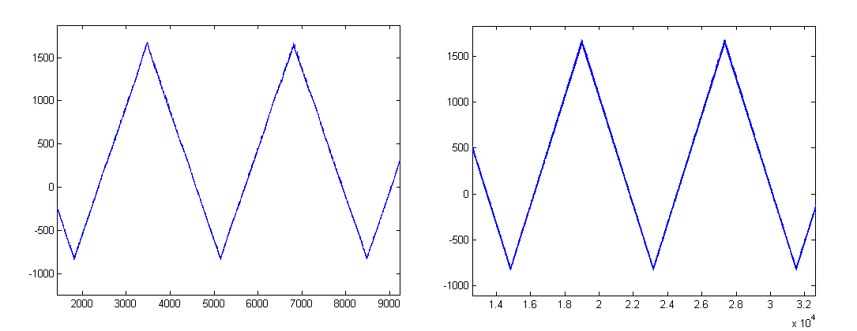
Figure ‎5.28: Method for measuring the Bluesense driver delay. Left figure shows the sampled signal in Bluesense and the right figure illustrates the sampled signal of National Instrument device.

Since both devices were connected to the same computer, the absolute time was the same for both data. T1 indicates the time after data being received in BCI2000 while T2 implies the absolute time the data sampled. As the same signal applied to both devices the time deference shows the delay of the BluesenseAD driver. Finding the exact extremes point is not as easy as it looks at the first glance. Any instruments have its own measuring error, so the value is not exactly the same as generated signal. In particular points that we are interested (e.g. Minimum), finding the exact extremes point is impossible. Therefore, we decided to take average of an interval and define the middle of the interval as extreme point. Figure 5.2 illustrates the sampled signal from BluesenseAD at minimum point. As it is obvious, the exact minimum cannot be defined due to the bouncing behavior of the signal. The averaging techniques, calculates more precise than just taking the local minimum value.

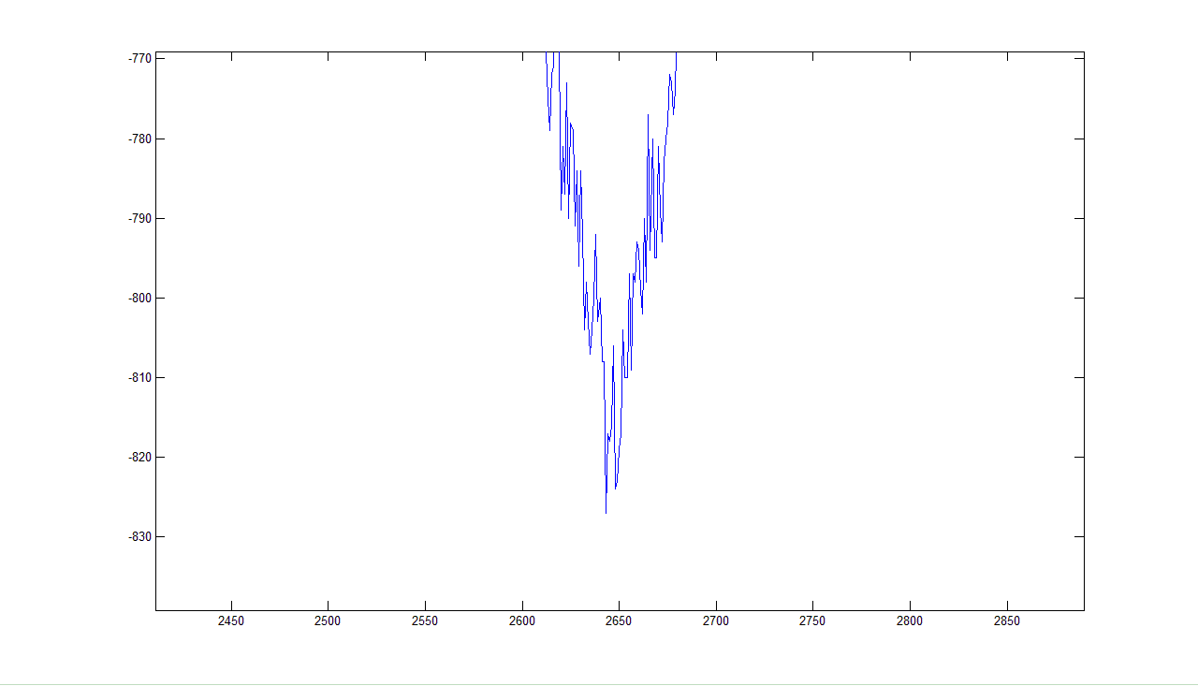
Figure ‎5.29: BluesenseAD sampled triangular signal at minimum point. The exact minimum cannot be defined.

The BCI2000 lets us to define Block size as well as sampling rate and number of active channels. The sampling rate indicates the frequency of sampling data for AD converter. Since data in BCI2000 carries in blocks of data, the Block size is defined to let the user pick the desired value according to his system. BluesenseAD has 8 AD channels that can sample data in different frequencies; it can be configured for any number of active channels which could be done through BCI2000 interface.
In BCI the data is usually sampled at 100Hrz to 250Hrz, thus we tested the system for the extremes values (100 and 250 Hertz). The Block size can be any value, but usually we use 16 or 32. Anyway, the system was tested using Block size equal to 2, 16, 32 and 64. The evaluation was repeated for 1 active channel, 4 active channels and 8 active channels.
This section will be concluded by mentioning the signal specification we applied besides introducing our signal collector device.
The specification of the triangular signal:
Amplitude = 1VPP
Frequency = 30 Mili-Hz
The frequency is chosen relatively small because of simplifying the selection of extremes points. Furthermore, if the frequency is too high it can degrade the perception of signal by BluesenseAD (Nyquist–Shannon sampling theorem).
National Instruments Data Acquisition Product has been used as a mirror signal collector beside BluesenseAD. It can sample data at the frequency of 1.25MHrtz with the accuracy of 16 bits for each sample. We sampled data at the frequency of 10 kilo hertz which is hundred times bigger than sample rate of BluesenseAD and gives us the accuracy of millisecond for timestamps.

Results and discussion
As we mention before, the data is collected using 100Hrz and 250Hrz sample rate for Block size of 2, 16, 32 and 64 for 1, 4 and 8 active channel(s). The results will be discussed based on the active channels in the following sections.

One Active Channel
Table 5.1 presents the expected delay when only one channel was being used for sampling data. First column indicates the number of channel was being used. The second column shows the Block size. The third column shows the frequency of sampling and the last column indicates the computed average delay for those combinations in millisecond.

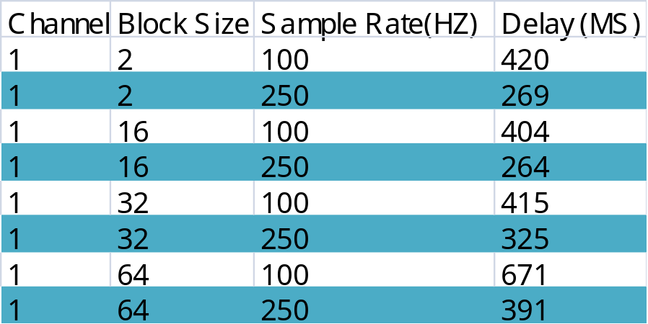
Table ‎5.3: Measured Delay (in millisecond) for various Block size and sample rate (in Hertz) using one active channel

When the Block size remains the same the Delay for higher sample rate is smaller which complies with the theory. But let’s keep the sample rate same and look at the delay. For sampling rate of 100Hz when the Block size increases the delay shows a strange behavior. Usually it is expected that the delay gets up when the block size increases because the system should wait longer to fill one Block of data. However, we have inconsistency when the Block size goes from 2 to 16. The abnormality cannot be understood without considering the behavior of the BluesenseAD chipset. BluesenseAD microcontroller sends sampled data whenever the data length reaches to the certain size. The size of the sample data depends on the number of active channels and sample frequency. Higher channel number and/or sample rate result in more data thus the BluesenseAD sends packet more frequently. When the sampling rate is equal to 100Hz and only one channel is active the delay of filling and sending packet in BluesenseAD microcontroller gets higher. But these packets usually contain enough data to fill the Block with size 16. So when the block size is 2, it waits the longer time to receive one packet which can fill 8 blocks of data, these extra iterations lead in greater delay in the system. However when the block size is big enough the delay of sending packet from BluesenseAD can be neglected. As it can be seen, this difference decreases when the frequency increases.
As we mentioned before, roughly half a second or 500 millisecond is an acceptable delay in our real-time system. The second to the last row in Table 5.1 is the only combination that results in greater time delay. That combination will never be used in the real experiments so there is no need to be concerned about. This big delay can be explained by the fact that the frequency is small and only one channel is active, thus it takes more time for BluesenseAD to construct and send packet and those packets do not contain enough data to fill blocks of 64, therefore the system waits long time to get one block filled and passes it to the next step.

Four Active Channels
Table 5.2 presents the expected delay when four active channels were being used for sampling data. First column indicates the number of channel was being used. The second column shows the Block size. The third column shows the frequency of sampling and the last column indicates the computed average delay for those combinations in millisecond. The delay for each channel is also shown in the table.

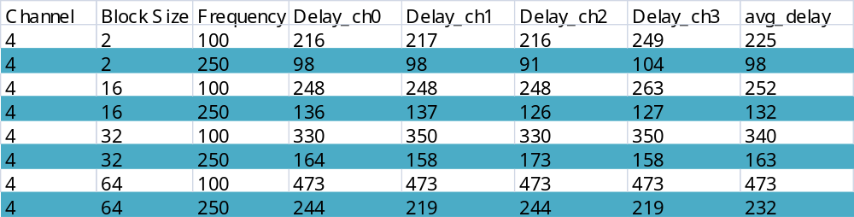
Table ‎5.4: Measured Delay (in millisecond) for various Block size and sample rate (in Hertz) using four active channels

The delay of different channels for the same combination is so close to each other and for some rows it is exactly the same. This indicates that the BluesenseAD evenly sends the data for each channel and each packet contains the sampled data for all channels (complies with Bluesense’s datasheet).
All statements mentioned for one channel also hold for this table. Greater sample frequency results in less delay while larger block size increases delay. However the inconsistency that was observed in the previous experiment cannot be seen in this measurement. Since the BluesenseAD packs sampled data for 4 channels in one packet, it does not need to wait till more data gets ready. The delay inside Bluesense’s microcontroller is eliminated, thus the result is accordant with theory.
For same Block size and sample rate, the average delay of 4 channels is considerably less than 1 active channel. This is because of the BluesenseAD’s behavior for generating and sending packets as mentioned before. More number of active channels causes more data being generated from AD convertors, so the Bluesense needs to wait less time to create a packet and send it. In general for same sample rate, the greater number of channels decreases the average delay. As we will see, the delay for 8 channels is even smaller.

Eight Active Channel
Table 5.3 presents the expected delay when eight active channels were being used for sampling data. First column indicates the number of channel was being used. The second column shows the Block size. The third column shows the frequency of sampling and the last column indicates the computed average delay for those combinations in millisecond. The delay for each channel is also shown in the table. As we will discuss later, the BluesenseAD does not support 250Hz sampling rate in 8 channels mode, thus the data is presented for 150Hz sampling rate.
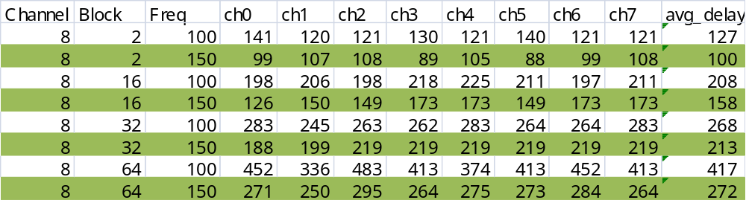
Table ‎5.5: Measured Delay (in millisecond) for various Block size and sample rate (in Hertz) using eight active channels

The same discussion mentioned for 4 channels also hold for this table. When the number of channels increases the average delay decreases, however since the data are presented for 100Hz and 150Hz the comparison cannot be accurately made. Larger Block size results in larger delay while greater sample frequency decreases the average delay. As in our BCI experiments we usually use more than 4 electrodes (channels), this table has precious values regarding to the average delay.
For usual experiment with sample frequency of 150Hz or 250Hz, Block size of 32 and number of active channels greater than 4, the average delay cannot be larger than 213 milliseconds which is less than the half of our acceptable delay.

Summary of Results
The results of the previous three experiments can be summarized in the Table 5.4. The table can be interpreted in this way:
- First row: If Block size and Sample Frequency remain constant and Channel number increases, the Delay will decrease.
- Second row: If the Channel number and Sample Rate are kept constant, increasing the Block size results in greater delay, however this fact is not true for 1 channel when the block size increases from 2 to 16.

Channel | Block | Freq | Delay
 |  |  | Except 1CH from Block 2 to 16
1 | 16 | 250 | Best performance 264
4 | 2 | 250 | Best performance 98
8 | 2 | 150 | Best performance 100
8 |  | > 150 | Corrupted Output
Table ‎5.6: The behavior of BluesenseAD driver for various configurations

- Third Row: While Block size and number of active channel remain the same, increase in frequency sample causes the decrease of average delay.
- Forth to Sixth Rows: They indicate which configuration gives the best performance or least delay in the system for different channel size.
- Last Row: It highlights the fact that the maximum supported sampling rate in 8 channels mode is 150 Hertz.

BluesenseAD Scalability
The BluesenseAD can sample data at different frequencies from any of its channel. It could be configured to sample from 1 to 8 different channels in different frequencies, but based on the number of sampling channels the maximum supported frequency varies, for more active channel less frequency can be achieved. In this section we will look into the behavior of BluesenseAD as the sample frequency gets higher. The delay is not the main concerned in this evaluation. We just want to find out the maximum sample frequency support for various active channels. Our method is so simple; we applied the same triangular signal we used for Bluesense delay measurement and looked at the output signal diagram in the long period of time (e.g. an hour). We increased the sample frequency till the signal graph (plotted in Mathlab) is disordered, so the last acceptable result is considered as maximum supported sample frequency for specified channel number. Figure 5.3 shows the plotted data sampled by BluesenseAD when the configured frequency is higher than supported value. The disorder manner of the sampled signal is clearly apparent in the figure.

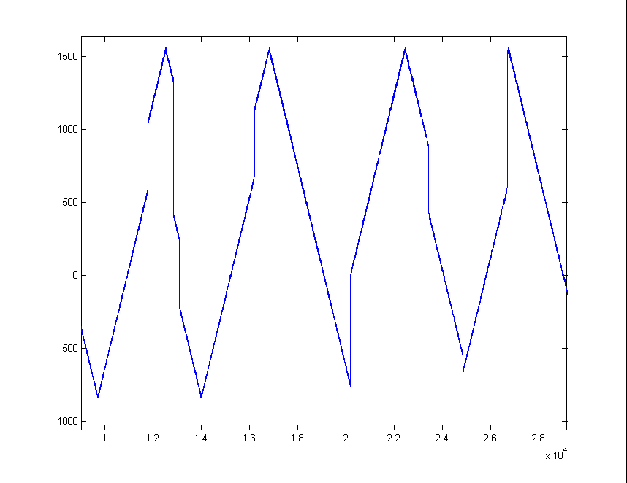
Figure ‎5.30: Unacceptable sampled data because of high frequency sampling

As it was mentioned before, the sampling frequency was increases until we got the disorder output. The maximum sampling rate for various numbers of channels is presented in Table 5.5. For example: when only one channel is sampling the sampling frequency can be configured up to 4000Hz but greater value may result in data loss. The chip was tested for frequency of 4100Hz and the result was not acceptable.

Number of Channels | Max Supported Frequency | Frequency caused clutter
1 | 4000 | 4100
2 | 3200 | 3300
3 | 600 | 650
4 | 280 | 300
5 | 250 | 280
6 | 250 | 256
7 | 230 | 250
8 | 160 | 190
Table ‎5.7: Maximum sampling rate for various numbers of channels, values are presented in Hertz

When Bluesense is sampling data from more channels, the maximum sampling frequency is declined for each channel. This is related to the limited capabilities of BluesenseAD which has been also mentioned in its datasheet. The microcontroller inside Bluesense chipset has limited computation power and resources, thus it cannot process more than certain amount of data at the time. Furthermore, the Bluetooth connection has also limited speed; therefore, if the chip wants to sample data faster than sending speed, some packets have to be dropped. The reason the output signals get disordered when the frequency gets higher than permitted value, is either because of this packet loss or data missing at AD convertors.

Video Game, Breakout, Evaluation
We want to show that our Video Game is a good output application for BCI systems and can be used instead of common Cursor Task application. The Breakout game was chosen because it is objective, easily implemented, simple for the user to learn, and can serve as a prototype for control of a wide variety of applications. It is necessary to mention that this evaluation will not be about correctness of the software or network capabilities of the software instead we will focus on showing the compatibility of the Video Game to be used in BCI experiments.

Parameters Definition
The Cursor Task in BCI2000 has some parameters to show the performance of the subject in BCI experiments such as Number of Hit and successful Rate. When the subject manages to hit the cursor to the correct target it is considered as a Hit and if he hits the wrong target is defined as Miss and if in the certain amount of time he cannot hit any targets it is considered as an Invalid trial. The Rate is defined as number of Hit minus Invalid trials divided by number of the whole trials. Since we want to compare the performance of the Game with the results of the Cursor Task, the same parameters have been defined for Breakout game. Beside that we declared some more criteria for better measurement of the subject performance. The list below shows all the parameters that have been defined following by their meanings:

- Trial: Number of experiment running
- Hit: Number of hitting the bar to the green indicator
- Failed: Number of moving the bar to the opposite direction of green indicator. The distance of bar to the green indicator is calculated and whenever the bar is moved to the opposite direction (same distance) it is considered as Failed.
- Aborted: Number of experiments that does not lead to Hit or Failed.
- CMR: Number of correct movement to the right. If the bar is supposed to be move to the right (green indicator is situated at left) each single correct movement increment CMR.
- CML: Number of correct movement to the left.
- WMR: Number of wrong movement to the right. If the bar is supposed to be moved to the right (green indicator is situated at left) each single wrong movement increases WMR.
- WML: Number of wrong movement to the left.
- Rate: (Hit – Abort)/Trial

CMR, CML, WMR and WML all together represent the number of control signals received by the game. If CMR be greater than WMR it means the subject has good control on right movement but if there be the same or less it means the controlling signals are almost random. The Rate is determined by the same formula used in Cursor Task so we can compare the results with BCI2000 outcome.

Method
The brain signals data were obtained using EEG from four male subjects at the University of Sydney. The selected volunteer participants were between 20-40 years old with no experience using the game, and only little experience using BCI systems. All participants signed a formal consent form approved by HREC of the Sydney University, prior to the EEG training and playing BCI video game.
Participants were fitted with a head-mounted EEG cap signals were acquired from three electrode sites C3, Cz & C4 according to the international 10/20 system. A bipolar signal was recorded using the Cz as the ground. Because of this, similar levels of activity over the two hemispheres would produce ‘low’ mu. That is, if both hemispheres exhibit either high or low levels, the difference would be seen as ‘low’ mu. Likewise, a difference in activity over the two hemispheres would produce ‘high’ mu. EEG activity was recorded at a sampling rate of 250 Hz using a bandpass filter of 0.1100 Hz (10 dB) and an amplification ranging from 10 000 to 20 000 (depending on the subject’s baseline mu power).
Participants sat in a comfortable chair with armrests, and asked to look straight ahead at a computer monitor that displayed a high-resolution Breakout video game. To familiarize participants with the control scheme of the video game a free running period was performed, where subjects were asked to explore the game by pressing the keys on the keyboard to move the Breakout. Right and left movements were controlled by ‘high’ and ‘low’ mu, respectively. At the end of the free-running period, participants began either the left or right-movements. Subjects were instructed not to touch the keyboard (thus, keeping the environment on the screen stationary), but to attempt to rotate it left or right by producing ‘low’ or ‘high’ mu, respectively. The left movement was performed while the participant was told to focus on moving the left arm. Similarly, for the right movement, the participants were asked to focus on the right arm. After completion of each game experiment, the subjects were asked to perform the Cursor Task. Thus, each subject first played Breakout for 20 trials and then performed the Cursor Task for 2 minutes which is about 20 trials. The experiment was repeated for 4 sessions (Cursor Task and Game). Then the outcome of both experiments was compared in order to show that the Game performance is approximately the same as Cursor Task outcome. Since we are interested to compare the results, the experience of the subjects is not our concerned. If the subject is beginner, the result for both applications should be low and if he is experienced the result would be good for both programs.

Results and discussion
Table 5.6 shows, the four participant’s statistics. For each subject two tables has been presented. The first one is related to the Curser Task outcome while the second one shows the results for Breakout. The definitions for parameters have already been given in previous sections. We are interested to compare the values of orange boxes in order to prove the usability of Breakout in BCI systems.
(a) Subject A’s Results
Cursor Task |  | Trial |  |  | Hit |  |  | Invalid |  |  | Rate
1 |  | 13 |  |  | 6 |  |  | 4 |  |  | 66
2 |  | 19 |  |  | 10 |  |  | 0 |  |  | 52
3 |  | 18 |  |  | 9 |  |  | 2 |  |  | 56
4 |  | 17 |  |  | 8 |  |  | 0 |  |  | 47
Sum |  | 67 |  |  | 33 |  |  | 6 |  |  | 54%
Breakout | Trial |  | Hit | Failed |  | Aborted | CMR |  | CML | WMR |  | WML | Rate
1 | 20 |  | 17 | 2 |  | 1 | 490 |  | 511 | 566 |  | 466 | 89
2 | 20 |  | 9 | 10 |  | 1 | 654 |  | 166 | 735 |  | 113 | 47
3 | 20 |  | 10 | 10 |  | 0 | 666 |  | 133 | 712 |  | 124 | 50
4 | 20 |  | 10 | 7 |  | 3 | 625 |  | 251 | 681 |  | 237 | 58
Sum | 80 |  | 46 | 29 |  | 5 | 2435 |  | 1061 | 2694 |  | 940 | 61%

(b) Subject B’s Results
Cursor Task |  | Trial |  |  | Hit |  |  | Invalid |  |  | Rate
1 |  | 24 |  |  | 13 |  |  | 0 |  |  | 54
2 |  | 26 |  |  | 11 |  |  | 0 |  |  | 42
3 |  | 17 |  |  | 9 |  |  | 0 |  |  | 52
4 |  | 26 |  |  | 12 |  |  | 0 |  |  | 46
5 |  | 21 |  |  | 12 |  |  | 0 |  |  | 57
Sum |  | 114 |  |  | 57 |  |  | 0 |  |  | 50%
Breakout | Trial |  | Hit | Failed |  | Aborted | CMR |  | CML | WMR |  | WML | Rate
1 | 20 |  | 6 | 6 |  | 8 | 686 |  | 445 | 873 |  | 339 | 50
2 | 20 |  | 7 | 7 |  | 6 | 817 |  | 401 | 869 |  | 386 | 50
3 | 20 |  | 9 | 7 |  | 4 | 828 |  | 421 | 883 |  | 405 | 56
4 | 20 |  | 9 | 9 |  | 2 | 713 |  | 234 | 760 |  | 220 | 50
5 | 20 |  | 7 | 7 |  | 6 | 822 |  | 414 | 855 |  | 405 | 50
Sum | 100 |  | 38 | 36 |  | 26 | 3869 |  | 1915 | 4240 |  | 1755 | 49%
(c) Subject C’s Results
Cursor Task |  | Trial |  |  | Hit |  |  | Invalid |  |  | Rate
1 |  | 20 |  |  | 9 |  |  | 0 |  |  | 45
2 |  | 22 |  |  | 12 |  |  | 0 |  |  | 54
3 |  | 22 |  |  | 13 |  |  | 0 |  |  | 59
4 |  | 22 |  |  | 11 |  |  | 0 |  |  | 50
Sum |  | 86 |  |  | 45 |  |  | 0 |  |  | 52%
Breakout | Trial |  | Hit | Failed |  | Aborted | CMR |  | CML | WMR |  | WML | Rate
1 | 20 |  | 7 | 6 |  | 7 | 769 |  | 497 | 799 |  | 484 | 53
2 | 20 |  | 8 | 5 |  | 5 | 693 |  | 282 | 787 |  | 241 | 53
3 | 20 |  | 9 | 4 |  | 4 | 785 |  | 369 | 823 |  | 359 | 56
4 | 20 |  | 8 | 5 |  | 5 | 783 |  | 317 | 834 |  | 278 | 53
Sum | 80 |  | 32 | 20 |  | 21 | 3030 |  | 1465 | 3243 |  | 1362 | 54%

(d) Subject D’s Results
Cursor Task |  | Trial |  |  | Hit |  |  | Invalid |  |  | Rate
1 |  | 18 |  |  | 9 |  |  | 1 |  |  | 52
2 |  | 17 |  |  | 13 |  |  | 1 |  |  | 81
3 |  | 18 |  |  | 9 |  |  | 1 |  |  | 52
4 |  | 19 |  |  | 9 |  |  | 0 |  |  | 47
Sum |  | 72 |  |  | 40 |  |  | 3 |  |  | 58%
Breakout | Trial |  | Hit | Failed |  | Aborted | CMR |  | CML | WMR |  | WML | Rate
1 | 20 |  | 7 | 2 |  | 11 | 537 |  | 823 | 596 |  | 689 | 77
2 | 20 |  | 11 | 0 |  | 9 | 404 |  | 842 | 407 |  | 803 | 100
3 | 20 |  | 12 | 2 |  | 5 | 417 |  | 756 | 436 |  | 673 | 80
4 | 20 |  | 14 | 0 |  | 6 | 488 |  | 721 | 493 |  | 662 | 100
Sum | 80 |  | 44 | 4 |  | 31 | 1846 |  | 3142 | 1932 |  | 2827 | 90%
Table ‎5.8: Four participant’s statistics, first table for each subject shows the results for Cursor Task while the second table presents Breakout outcomes

Since the analysis of different subject’s results is the same, we will only discuss the result of participant A. The rest of them can be interpreted in the same way. Table 5.6(a) shows the result of the subject A. The first table shows the outcomes of Cursor Task. It shows that the experiment was repeated four times and the subject achieved 54% Hit rate in average. Total number of 67 trials was performed and the subject was managed to hit the target 33 times. Only 6 invalid trials were occurred which implies the participant had enough time to hit the target either wrong or right. The average rate is 54% which shows the subject was partially able to control the cursor and he could hit the target in almost half of the trials. In the second table which shows the results of Breakout more information is provided. Beside the number of hit the Failed trials is also presented. Failed trial indicates that the participant moved the bar incorrectly to the opposite direction. CMR (Number of correct movement to the right) and WMR (Number of wrong movement to the right) values are greater than CML (Number of correct movement to the left) and WML (Number of wrong movement to the left), thus the subject moved the bar more to the right. However, since CMR is less than WMR, it shows the movement to the right occurred unintentionally. Probably some parameters in the system were not set correctly for this specific subject or he was not trained enough. On the other hand CML is greater than WML which indicates regardless of lower number of movement to the left, the subject had better control on left movement. Whenever the bar was supposed to be moved to the left, he generated the correct signal. Please notice that this information cannot be achieved from BCI2000 Cursor Task due to the limited number of assessment parameters. The average Hit rate for this subject is about 61% which is close to his result for Cursor Task (54%), so we showed our Video Game is a good candidate for BCI experiment.
The rest of the results can be interpreted in the same way, all subjects except participant D gained almost the same Rate for both Cursor Task and Breakout game. The last participant achieved very good result on the Breakout and relatively good on Cursor Task. The high Rate in Breakout game is due to the large number of Aborted which is not taken to the account for Hit Rate calculation. This means the subject could not hit the target at the given time but also he did not move the bar to the opposite side. Since the timing and cursor speed is different in Cursor Task and Breakout, it is likely the subject had enough time to hit the target in Cursor Task but not in Breakout; it also can be understood from the small Valid number in the first table (which is only 3). If the time for each trial in Cursor Task is decreased or the speed of the cursor is increased, probably the results get closer to the Breakout’s result.
By comparing the outcome of Breakout and Cursor Task for four different participants, we showed that our game generates almost the same Rate values as Cursor Task, thus it can be substitute in the BCI systems. The subject can easily be trained to switch from most well-known BCI output application to Breakout in less than half an hour and achieves almost the same performance as Cursor Task.

Conclusions and Future Work

Conclusion
In this study we have developed a distributed framework for controlling the Breakout video game through brain signals. The participants learn to control levels of controls (i.e. mu rhythms), but especially when this learning involves producing similar mu levels in each hemisphere. They are able to maintain that level of control across 5-6 training sessions. The distributed architecture of our gaming environment has two positive effects on the whole learning process.
Firstly, the brain data can be transmitted without the ribbon cable, allowing our participants to sit in a comfortable natural posture and concentrate on the video game control without any position specific distractions. Secondly, having data processed on the PC separate to the video game console gives low delays in the control signals, whereas the computation power of signal processing and feature extraction becomes exponentially higher.

BluesenseAD has been used as a Bluetooth device to collect and transfer EEG signals to the signal processing module on a PC. A new driver compatible with BCI2000’s signal acquisition module was developed to let the BCI2000 application acquire EEG signals via established virtual serial port over Bluetooth connection. In the evaluation section, it has been shown that this device is reliable and robust to be a mean of communication in BCI systems. By introducing a new method, the delay of the entire acquisition, AD converters, transmission and data process have been calculated and it has been demonstrated that its value is acceptable for our proposed real-time architecture. The maximum sampling rate for various numbers of active channels has been investigated and we showed that the supported sampling rate decreases when the more channels are activated.

BCI2000 is capable of sending control signals for an external output device via UDP. To make the Breakout less dependent on BCI2000 and also keep the code as simple as possible on the mobile side and mostly because of adding TCP support, we developed a Game Server application which sits between BCI2000 and Video Game and interprets the control signal in Video Game language. In the implementation section we went through the code and we explained how this application basically works.

The last part of this thesis was about developing the Video Game that would be suitable for BCI experience and can be run on Java-enabled handsets. This game should also be simple enough to avoid subject’s distraction and further it could be controlled by only two control signals. Breakout was selected which later we changed it a bit to make it more suitable for BCI experiments. The bricks have been removed to reduce subject’s distraction and the green indicator is added to make the game closer to synchronous BCI. In the evaluation section by comparing the performance of Breakout and Cursor Task application, we showed that our game can serve as a BCI output device. The subjects were able to get controlled over the game after half an hour practice.

This project helped me to get familiar to the new field of science. Besides using my knowledge in telecommunication for developing Bluesense Driver and wireless Video Game, I learnt a lot in BCI field.

Future Work
This study has opened new interesting opportunities for the future work. Some of the most important future improvements are:

- Asynchronous BCI
In this study the synchronous BCI was successfully implemented and tested. The next step could be involving the asynchronous BCI where the system works both for intentional and unintentional brain’s signal.
- Hybrid Systems
As it was mentioned in the previous section, EEG BCI can further break into several systems (i.e. Mu/Beta Rhythm, SCPs and P300). While each of them has their own advantages and inefficiencies, a hybrid system which uses the combination of these systems could take advantage of the benefits of all solutions. Since all these methods are based on EEG, the brain signals could be collected through the same device but from different part of the scalp. Any of these techniques uses a completely different signal processing method; however they are aimed to control an output device thus the output of signal processing module would be control signals. In future, these control signals might be capable to be mixed together to generate more valid control signals.
- Virtual Reality
Later, the Video Game can be substituted by either the real or virtual robots. In the real case a robot that needs 5 control signals (left, right, up, down and stop) could be developed. If the hardware for robots cannot be provided, an application in virtual reality (VR) environment to simulate the real situation could be developed.
- Bluesense, Sniff Mode
We only developed the driver for Bluesense to work in the normal mode which consumes more power but provides faster connection. Later the driver can be modified a bit to let the Bluesense communicate in the Sniff Mode in which the power consumption decreases with scarification of the connection speed. However, in the environment that less bit rate is needed the Sniff Mode could considerably save a battery.
- Bluesense, Security
Since the Bluesense has been used only in the research lab, we did not find it important to implement the security for Bluetooth connection which means the connection can be disturbed by any other Bluetooth enabled device. In the next level the security can be developed for Bluesense driver which will let both sides act as a pair Bluetooth device.

References

